OFFER FORM ACTED [PAKISTAN]

Tender N° (filled in by ACTED): T/04GEN/M1PDRM/ISL/09.01.2026/07

Order ID (filled in by ACTED): OF/04GEN/M1PDRM/ISL/06.01.2026/07

Date (filled in by Bidders):

To be Filled by Bidder (COMPULSORY)
Company’s Name
(as per registration documents)
Company Authorized Representative’s Name
(as per registration documents or duly signed Power of Attorney)
Company Registration Number
Registration body
Company’s mailing address
Shop/Office/Building No
Street name
City
Governorate/province/district
Country
Commercial representative for the bid
(if different from authorized representative)
Phone contact number
Landline
Mobile No
Email address

I undersigned (to be filled in by the Bidder) _____________________________________________________________________________________________________
agree to provide ACTED, non-profit NGO, with items answering the following specifications, according to the general conditions and responsibilities that I engage myself to follow.
Please fill in the following tables, one for each lot:
- The Bidder may bid for one or all lots. Each lot may be subject to a separate contract and the quantities indicated for the different lots cannot be divided. The Bidder must offer all items & quantities indicated for each lot. Bids for part of a lot only will not be considered.
- If the Bidder is awarded more than one lot, a single contract may be concluded including all lots.
- 5 % Bid Security is required to be submitted for each lot applied.
Unit and Total prices must be inclusive of all costs (materials, equipment, workers, insurances, etc.)

Construction/Rehabilitation of disaster resilient model community Shelter for 3 District Sanghar, Jacobabad & Jaffarabad (5 Nos per District) - Total Quantity 15 Nos

Lot 1: Construction/Rehabilitation of disaster resilient model community Shelter (District Sanghar)
 | To be filled in by ACTED |  |  |  | To be filled in by the Bidder
N° | Works Deliverables | Unit | Per Site Quantity | Total Quantities  (1) | Unit Price including all costs & taxes  (PKR)  (2) | Total Price including all costs & taxes  (PKR)  (1) x (2)
A | Evacuation center | Total Sites - 5
1 | Excavation for foundation, evacuation center (Platform) in clay including removing all vegetation alongwith roots and back filling selected excavated material in foundation, plinth or under floor. Quantity variation (±) shall be adjusted as per actual site conditions. | Cft | 1348 | 6740
2 | Providing and filling earth (25% of sand) leveling, watering, dressing and lyerwise compaction after each 12 cm complete in all respect. Quantity variation (±) shall be adjusted as per actual site conditions. | Cft | 45000 | 225000
3 | Providing and placing stone/brick ballast 1/2''-3/4'' angular, compection/ramming with hand hammed under floor/foundation mix with15% of sand. Quantity variation (±) shall be adjusted as per actual site conditions. | Cft | 1339 | 6695
4 | Providing & laying 1:3:6 (1 cement 3 sand and 6 coarse aggregate) cement concrete using graded crush ¾ inch (20mm) and down gauge in foundation including levelling, compacting and curing, etc., complete. Quantity variation (±) shall be adjusted as per actual site conditions. | Cft | 372 | 1860
5 | Providing & laying 1:2:4 (1 cement 2 sand and 4 coarse aggregate) cement concrete using graded crush ¾ inch (20mm) and down gauge in foundation including levelling, compacting and curing, etc., complete. Quantity variation (±) shall be adjusted as per actual site conditions. | Cft | 154 | 770
6 | Providing and laying DPC of 2 inch (50mm) thick machine mixed 1:2:4 cement concrete using graded crushed boulders 3/4 inch (19mm) and down gauge including form work, consolidation, finishing, curing etc., complete. Quantity variation (±) shall be adjusted as per actual site conditions. | Sft | 338 | 1690
7 | Pacca Brick work first class solid burnt brick masonry set in cement mortar 1:4 in straight or curved walls 9" to 13-1/2 inches (228 mm to 343 mm) thick including scaffolding, raking out joints and curing, etc., complete in foundation, basement and plinth, including, all lead and lift. Quantity variation (±) shall be adjusted as per actual site conditions. | Cft | 4890 | 24450
8 | Providing and applying 1/2" (13mm) thick cement plaster 1:4 on walls etc., including making edges, corners, and curing for 15 day, etc., complete. Quantity variation (±) shall be adjusted as per actual site conditions. | Sft | 4561 | 22805
B | Shelter
1 | Excavation for foundation, for shelter in clay including removing all vegetation alongwith roots and back filling selected excavated material in foundation, plinth or under floor. Quantity variation (±) shall be adjusted as per actual site conditions. | Cft | 671 | 3355
2 | Providing and filling earth (25% of sand) leveling, watering, dressing and lyerwise compaction after each 12 cm complete in all respect. Quantity variation (±) shall be adjusted as per actual site conditions. | Cft | 3000 | 15000
3 | Providing & laying 1:3:6 (1 cement 3 sand and 6 coarse aggregate) cement concrete using graded crush ¾ inch (20mm) and down gauge in foundation including levelling, compacting and curing, etc., complete. Quantity variation (±) shall be adjusted as per actual site conditions. | Cft | 111 | 555
4 | Providing and laying DPC of 2 inch (50mm) thick machine mixed 1:2:4 cement concrete using graded crushed boulders 3/4 inch (19mm) and down gauge including form work, consolidation, finishing, curing etc., complete. Quantity variation (±) shall be adjusted as per actual site conditions. | Sft | 179 | 895
5 | Pacca Brick work first class solid burnt brick masonry set in cement mortar 1:4 in straight or curved walls 9" to 13-1/2 inches (228 mm to 343 mm) thick including scaffolding, raking out joints and curing, etc., complete in foundation, basement and plinth, including, all lead and lift. Quantity variation (±) shall be adjusted as per actual site conditions. | Cft | 3519 | 17595
6 | Providing and placing stone/brick ballast 1/2''-3/4'' angular, compection/ramming with hand hammed under floor/foundation mix with15% of sand. Quantity variation (±) shall be adjusted as per actual site conditions. | Cft | 19 | 95
7 | Providing and laying machine mixed reinforced cement concrete(for slabs) using graded crushed boulders 3/4 inch (19mm) and down gauge having a minimum works cube crushing strength of 3000 lbs.per sq. inch(20 N/mm2) at 28 days with a mix not leaner than 1:2:4 including form work and its removal, compacting and curing, etc., including all lead and lift. Quantity variation (±) shall be adjusted as per actual site conditions. | Cft | 93 | 465
8 | Providing & laying mild steel reinforcement bars with minimum yield stress of 40,000 Psi with and including the cost of straightening, cutting, bending, binding, wastage, and such overlaps as are not shown over the drawings, placing in position on cement concrete 1:2:4 precast or M.S. chairs, tying with binding wire, cost of chair and wires, etc., in all kinds of RCC work in foundation, basement, plinth, ground, and all floors of building including septic tank, underground tank and in projections for future extension. Quantity variation (±) shall be adjusted as per actual site conditions. | Kg | 293 | 1465
9 | Providing and applying 1-inch (26 mm) thick mud plaster mixed with wheat straw on walls and columns, complete on all aspects. Quantity variation (±) shall be adjusted as per actual site conditions. | Sft | 4462 | 22310
10 | Providing and fixing steel girders of size 4" × 8" with a unit weight of 3.5–4.0 kg per running foot. The scope includes all necessary handling, cutting, alignment, and fixing as required for proper installation.  Finish shall include one coat of red oxide primer followed by two coats of enamel paint. Quantity variation (±) shall be adjusted as per actual site conditions. | Rft | 163 | 815
11 | Providing, fixing, and welding Tee Iron sections of size 70 mm × 35 mm (6 mm thick), with a unit weight of 1.92 kg per running foot, to function as rafters in conjunction with the Girder/T-Iron. The scope includes all required cutting, alignment, and welding for proper installation.  Finish shall include one coat of red oxide primer followed by two coats of enamel paint. Quantity variation (±) shall be adjusted as per actual site conditions. | Rft | 234 | 1170
12 | Providing, fixing, and welding MS pipe sections of size 6" × 3" (150 × 75 mm), with a wall thickness of 3 mm and a minimum weight of 3 kg per foot, to be used as king posts. The work shall include all necessary cutting, alignment, and welding as required.  Finish shall include one coat of red oxide primer followed by two coats of enamel paint. Quantity variation (±) shall be adjusted as per actual site conditions. | Rft | 18 | 90
13 | Providing, fixing, and welding MS pipe sections of size 4" × 2" (100 × 50 mm), with a wall thickness 3 mm and a minimum weight of 2 kg per foot, to be used on top of king posts. The work shall include all necessary cutting, alignment, and welding as required on site.  Finish shall include one coat of red oxide primer followed by two coats of enamel paint. Quantity variation (±) shall be adjusted as per actual site conditions. | Rft | 57 | 285
14 | Providing, laying, and securing Chhawari-grade, Termite treated good quality bamboo over trusses/struts, including tying with binding wire. Bamboo shall be of good quality with a minimum diameter of 2 inches at the smaller end and a minimum wall thickness of 0.5 inches. The work shall include one coat of red oxide paint on all bamboo members.  Quantity variation (±) shall be adjusted as per actual site conditions. | Rft | 3440 | 17200
15 | Providing and laying Chicks (Size 4 ft x8ft) with minimum 1/3 inch dia sticks closly binded with jute (sotlee) rope. +&-will be adjust as per actual | Sft | 3016 | 15080
16 | Providing and laying Polythene sheet, 250 micron, 1000 gauge, heavy duty, as per instruction of engineer in charge. +- will be adjust as per actual | Sft | 3016 | 15080
17 | Providing and applying 2-inch thick mud plaster mixed with wheat straw, (Excluding the cost of wheat straw, this will be provided by community), prepared and laid in accordance with the instructions and specifications provided by the Engineer-in-Charge. Quantity variation (±) shall be adjusted as per actual site conditions. | Sft | 3016 | 15080
18 | Providing and fixing wooden Doors 5 feet wide and 7 feet height including chowkat. Kikar (Acacia) wood.  Chowkat: 5"width x 3" thickness, Door Frame: Width 4", thickness 1.5", door panels Thickness minimum 1". Panels frame width may be in between 3" to 2". Siutable design on front side, including fixing on site and all required hinge, both way (internal/external) handle and locking arrangements, Including two coats of paint. Complete in all respects. | Nos | 2 | 10
19 | Providing and fixing wooden Windows 3 feet wide and 4 feet height, including chowkat. Kikar (Acacia) wood  Chowkat: 3"width x 3" thickness, Door Frame: Width 2", thickness 1.5", door panels Thickness minimum 1". Panels frame width may be in between 2" to 1.5". Siutable design on front side, including fixing on site and all required hinge, internal side handle and locking arrangements, Including two coats of paint. Complete in all respects. | Nos | 14 | 70
C | Toilet (6'x6'x8')
1 | Excavation for foundation, Toilets (rectangular or square), trenches and drains in all kinds of soil including rock and removing all vegetation alongwith their roots and back filling selected excavated material in foundation, plinth or under floor. Quantity variation (±) shall be adjusted as per actual site conditions. | Cft | 641 | 3205
2 | Providing and layig Dry rammed/compected Brick/Stone ballast under floor/foundation mix with 25%sand. Quantity variation (±) shall be adjusted as per actual site conditions. | cft | 73 | 365
3 | Providing & laying 1:3:6 (1 cement 3 sand and 6 coarse aggregate) cement concrete using graded crush ¾ inch (20mm) and down gauge in foundation including levelling, compacting and curing, etc., complete. Quantity variation (±) shall be adjusted as per actual site conditions. | Cft | 73 | 365
4 | Pacca Brick work first class solid burnt brick masonry set in cement mortar 1:5 in straight or curved walls 9" to 13-1/2 inches (228 mm to 343 mm) thick including scaffolding, raking out joints and curing, etc., complete in foundation, basement and plinth, including, all lead and lift. Quantity variation (±) shall be adjusted as per actual site conditions. | cft | 1132 | 5660
5 | Providing and laying DPC of 2 inch (50mm) thick machine mixed 1:2:4 cement concrete using graded crushed boulders 3/4 inch (19mm) and down gauge including form work, consolidation, finishing, curing etc., complete. Quantity variation (±) shall be adjusted as per actual site conditions. | Sft | 115 | 575
6 | Providing & laying 2'' thick 1:2:4 mix (1 cement 2 sand and 4 coarse aggregate) cement concrete using graded crush ¾ inch (20mm) and down gauge in floor including levelling, compacting and curing, etc., complete. Quantity variation (±) shall be adjusted as per actual site conditions. | Sft | 504 | 2520
7 | Providing and laying machine mixed reinforced cement concrete(for slabs) using graded crushed boulders 3/4 inch (19mm) and down gauge having a minimum works cube crushing strength of 3000 lbs.per sq. inch(20 N/mm2) at 28 days with a mix not leaner than 1:2:4 including form work and its removal, compacting and curing, etc., including all lead and lift.Quantity variation (±) shall be adjusted as per actual site conditions. | Cft | 54 | 270
8 | Providing & laying mild steel reinforcement bars with minimum yield stress of 40,000 Psi with and including the cost of straightening, cutting, bending, binding, wastage, and such overlaps as are not shown over the drawings, placing in position on cement concrete 1:2:4 precast or M.S. chairs, tying with binding wire, cost of chair and wires, etc., in all kinds of RCC work in foundation, basement, plinth, ground, and all floors of building including septic tank, underground tank and in projections for future extension. Quantity variation (±) shall be adjusted as per actual site conditions. | KG | 71 | 355
9 | Providing and applying 1/2" (13mm) thick cement plaster 1:4 on walls etc., including making edges, corners, and curing, etc., complete. Quantity variation (±) shall be adjusted as per actual site conditions. | Sft | 1823 | 9115
10 | Providing, laying, and securing Chhawari-grade, Termite treated good quality bamboo for toilet roof. Bamboo shall be of good quality with a minimum diameter of 2 inches at the smaller end and a minimum wall thickness of 0.5 inches. The work shall include one coat of red oxide paint on all bamboo members.  Quantity variation (±) shall be adjusted as per actual site conditions. | Rft | 272 | 1360
11 | Providing and laying chicks with sticks of minimum 1/3 inch diameter, tightly bound together using jute (sotlee) rope, as per specifications. Quantity variation (±) shall be adjusted as per actual site conditions. | Sft | 204 | 1020
12 | Providing and applying 2-inch thick mud plaster mixed with wheat straw, (Excluding the cost of wheat straw, this will be provided by community), prepared and laid in accordance with the instructions and specifications provided by the Engineer-in-Charge. Quantity variation (±) shall be adjusted as per actual site conditions. | Sft | 204 | 1020
13 | Providing and laying Polythene sheet, 250 micron, 1000 gauge, heavy duty, as per instruction of engineer in charge. +- will be adjust as per actual | Sft | 204 | 1020
14 | Providing and applying 2 coats of weather sheild paint on exterior surface of building, including surface preparation and applying three coats (ICI, Master,Happilac, Shell Brighto, Diamond) or same quality company (with a coverage of 130 Sft/litter). Quantity variation (±) shall be adjusted as per actual site conditions. | sft | 673 | 3365
15 | Providing and applying Vinyl emulsion Dulux or berger paint, 2 coats including preparation of surface. Quantity variation (±) shall be adjusted as per actual site conditions. | Sft | 904 | 4520
16 | Supplying and fitting 3/4'' ɸ (19 mm) PPRC pipe (under wall) for toilets with water points (8 for Tee cocks/flush tanks, 8 for WC & english commobe, 4 for shower and 4 extra out side the toilet for other usage). complete in all respect. | Rft | 130 | 650
17 | Providing and fitting 4 indian water closet (WC) standard size, Master, Polo, 3-Star or equavelent with 4'' Ф P-Trap of same brand | Nos | 4 | 20
18 | Providing and fitting 4 flush tanks of Honey Master, Adam, DWAN, or equavelent along with flexible pipe fixed with Tee cock, J pipe and all other accessaries required complete in all respect | Nos | 4 | 20
19 | Providing and fixing 4 English commode complete in all respects including Master RAVI C 1 (height with tank 850 mm, bottom width 735 mm height of seat 410 mm), equivalent or master, Porta, Faisal, including , P-Trap, flexible connection pipe, 3/4'' Ф 2 bib cocks 1 Tee/stop cock (steel with brass spindles Master/Faisal) Muslim shower of same brand and connecting with septic tank | job | 4 | 20
20 | Supplying and Fixing Polyethylene Water Tank made from food grade FDA Certified raw material, 3 layers UV stablized, inert with water, anti-fungus and anti-bacterial and have a service life of more than 10 years: 200 gallons (Imperial) 900 litres. (Horizontal) Master or equilant, including (i)- UPVC ball valve 3/4'' ɸ connecting with supply system (ii)- provide washout pipe with 1'' ɸ, UPVC handle valve, UPVC 1'' ɸ pipe for over flow complete in all respect. | job | 1 | 5
21 | Providing and fixing wash basin (standard size) Master/equivalent along with pedestal, flexible connecting pipes with tee cocks, basin faucets in (water tape) double (master or equivalent brands) complete in all respect connect with drainage pipe (30-40 feet away) | job | 4 | 20
22 | Providing and fixing steel ventilators 2' x 1.5' using 1''x1'' angle iron frame, with 2/16'' Ф steel rods, two coats of synthetic enamel paint in adition to one coat of primer/rust proof paint and galvanised wire gauze, 22 guage and 144 mesh to a square inch. Quantity variation (±) shall be adjusted as per actual site conditions. | Nos | 4 | 20
23 | Providing and fixing steel doors 3' x 6.5' of M.S sheet 20 SWG including all necessary steel fittings, hold fasts and two coats of synthetic enamel paint in addition to one coat of primer/rust proof paint including bolts hinges etc and frame of 1.5" x1.5" x 1/16'' (1.5875 mm) angle iron frame. Quantity variation (±) shall be adjusted as per actual site conditions. | Nos | 4 | 20
24 | Electrification with AC & DC wiring for two ligh point (1 inside & 1 outside) in each toilet with 3/29 cables and recommended cable for DC fitting with LED and DC blubs (20 watt) one each including a china board with 2 light point and 2 socket points, and on/off system for DC lighting and connecting with solar/battry system | job | 8 | 40
25 | Construction of two washing pad (6'x6') with brick masonary, cement plaster and drain pipe out side the toilet (as per drawing), install two stand post tapes of 3/4'' and PPRC pipe fitting to connect with water tank [Near female Toilet) | job | 2 | 10
26 | Providing and fixing 3/4'' ɸ steel 3 mm thick (fine finished) grabs one number of [1 foot long], one number of 1'' ɸ 1.5' sleight bend 45° straighten 9'' fixed with Rawal bolts in both sides of walls near commode [3 no in each toilet] | job | 1 | 5
D | Water supply and plantation
1 | Hand or machine boring for borehole tubewell in all types of soil rock, from a depth of up to 50 ft below ground level, including sinking and withdrawing of casing pipe, complete. Quantity variation (±) shall be adjusted as per actual site conditions. | Rft | 60 | 300
2 | 2.5'' ɸ Providing and installing P.V.C. blind pipe, B.S.S. Class `B', (6 bar pressure/6kg/cm2) in tubewell bore hole, as casing including sockets and solvents and jointing with strainer, etc. complete (Pak Arab Jadeed/Hydroplast/National or equavalent reputeable company). Quantity variation (±) shall be adjusted as per actual site conditions. | Rft | 50 | 250
3 | Providing and installing, P.V.C. strainer B.S.S. Class 'B', in tubewell bore hole, as casing including sockets and solvents and jointing with blind casing pipe, etc.complete:- (Pak Arab Jadeed/Hydroplast/National or equavalent reputeable company) 2.5'' ɸ pipe. Quantity variation (±) shall be adjusted as per actual site conditions. | Rft | 10 | 50
4 | Providing and fixing of 2 hp DC Water pump (Sitar, Shahzad or equivalent), within borehole & anchoring of waterpump through rope support above NGL, (water pump having stainless steel or equivalent impeller, including AC/DC controller & 110 m - 3 core or equivalent capacity Cable for power supply to waterpump including waterproofing of electrical cable) including 1" PVC pipe (electrical conduit placed in 1" PVC pipe from power supply to waterpump) including plumbing connection (inlet & outlet of water pump) with PVC, HDPE type and necessary jointing (elbow, socket, union, tape, solution) complete in all respects. | job | 1 | 5
5 | Providing and fixing 3 solar Panels -monocrystalline (200 watt each) Renogy, longi, JASCO or equavalent with aluminium Frame (warrented by the company) and fixing on frame/stands, provide and installing DC/AC copper cable 10 mm or recommended by the company length as per requirement (50-80 meter) connecting with DC water pump and the inverter/converter if required including a circuit breaking switch.  Including M/S pipe frame of 2 in x 2 in rectangular (16 gauge) for installation of solar panels,with minimum 5 feet height at all 4 corners, attached in the roof with 6in x 6in plate, 16 gauge plate with rawal bolts, suitable to transfer any solar panel load onto roof. provison for attachable solar panels in a rigid / motion-free manner, including 2 layer of Iron oxide for rustproof. Complete in all respects. | job | 1 | 5
6 | Providing and installing 1 number of 100 amp/ah lead acid batteries (excide/AGS/OSAKA) connecting with DC water pump through a circuit breaker swithch, including auto charge controller upto 40 amp (Renogy Rover/Lumiax/SIMTEK or equavalent reputable company) or recommended for 100 amp batteries including on/off circuit breaking switch may be installed complete in all respect | job | 1 | 5
7 | Providing and planting 200 Nos seasonal trees, minimum 3 feet height, around the evacuation center and hand over to the UCDMC members | job | 200 | 1000
8 | Sign Board  Providing and fixing 4'x3' sign board including standards, braces piping and in similar open work: Three Coats and writing letters or figures, per letter, per inch (25 mm) height.MS sheet of 16 (guage) may be used and 2.5'' dia MS pipe may be used, fix in 1.5'x1.5' and 2' deep in ground with 1:2:4 mix | job | 2 | 10
E | Rainwater Harvesting Pond
1 | Excavation for foundation, Toilets (rectangular or square), trenches and drains in all kinds of soil including rock and removing all vegetation alongwith their roots and back filling selected excavated material in foundation, plinth or under floor. Quantity variation (±) shall be adjusted as per actual site conditions. | Cft | 600 | 3000
2 | Providing and layig Dry rammed/compected Brick/Stone ballast under floor/foundation mix with 25%sand. Quantity variation (±) shall be adjusted as per actual site conditions. | Cft | 124 | 620
3 | Providing & laying 1:3:6 (1 cement 3 sand and 6 coarse aggregate) cement concrete using graded crush ¾ inch (20mm) and down gauge in foundation including levelling, compacting and curing, etc., complete. Quantity variation (±) shall be adjusted as per actual site conditions. | Cft | 124 | 620
4 | Pacca Brick work first class solid burnt brick masonry set in cement mortar 1:4 in straight or curved walls 9" to 18" inches thick including scaffolding, raking out joints and curing, etc., complete in foundation, basement and plinth, including, all lead and lift. | Cft | 492 | 2460
5 | Providing and laying DPC of 2 inch (50mm) thick machine mixed 1:2:4 cement concrete using graded crushed boulders 3/4 inch (19mm) and down gauge including form work, consolidation, finishing, curing etc., complete. Quantity variation (±) shall be adjusted as per actual site conditions. | Sft | 85 | 425
6 | Providing and applying 3/4" thick cement plaster 1:3 on walls etc., including making edges, corners, and curing for 15 day, etc., complete. Quantity variation (±) shall be adjusted as per actual site conditions. | Sft | 894 | 4470
7 | Providing & laying 1:2:4 (1 cement 2 sand and 4 coarse aggregate) cement concrete using graded crush ¾ inch (20mm) and down gauge in floor, including levelling, compacting and curing, etc., complete. | Cft | 165 | 825
8 | Fensing: Providing and on-site fixing Fencing using Vertical & Horizontal Circular Iron post - M/S Pipe 2" Dia (having 16 gauge) (rust-free, 2 coats of red oxide layer), Vertical post 5.5 ft long (4ft above ground & 1 ft embedded within concrete) (with covered pipe caping) and 10 ft apart embedded in cement concrete (1:2:4) base (in soil & excavation included) of 8"x8"x1.5' size, including fixing side around waterpond with 3/4" dia U bolts. & Horizontal pipe running along the length of waterpond perimeter installed on top of vertical post Top level of fencing pipes to be at the same level maintaining the horizontal alignment in all respects. (Item is exclusive of concrete casting)  Including Providing and fixing hot dipped Galvanized Iron chain link mesh/fence (in between poles) of 2" x 2" & mesh made of wire of 8 SWG (standard wire gauge) , with the help of 1" x 1/8" GI patti, GI clamps and screws. Including Knuckle, knuckle chain arrangement. Wire mesh extended to the natural ground level & embedded in concrete).  Painting of posts 3 layer (including 2 red oxide layer & 1 weather protected coat), Includes 1 doors having 1 swing panel (5ft x 5ft size of one swing panel) at one corner of fence. Includes having arc welded hooks with padlock minimum 50 mm (with 3 spare keys) and heavy duty (8 ft) chain. Complete in all respects. Includes material, labor cost in all respects.  +/-, will be adjusted as per site | Rft | 85 | 425
F | Animal Shed - 40' x 15'
1 | Excavation for foundation, for Column in clay including removing all vegetation alongwith roots and back filling selected excavated material in foundation, plinth or under floor. Quantity variation (±) shall be adjusted as per actual site conditions. | Cft | 38 | 190
2 | Providing & laying 1:3:6 (1 cement 3 sand and 6 coarse aggregate) cement concrete using graded crush ¾ inch (20mm) and down gauge in foundation including levelling, compacting and curing, etc., complete. Quantity variation (±) shall be adjusted as per actual site conditions. | Cft | 7 | 35
3 | Providing and laying DPC of 2 inch (50mm) thick machine mixed 1:2:4 cement concrete using graded crushed boulders 3/4 inch (19mm) and down gauge including form work, consolidation, finishing, curing etc., complete. Quantity variation (±) shall be adjusted as per actual site conditions. | Sft | 19 | 95
4 | Pacca Brick work first class solid burnt brick masonry set in cement mortar 1:4 in straight or curved walls 9" to 13-1/2 inches (228 mm to 343 mm) thick including scaffolding, raking out joints and curing, etc., complete in foundation, basement and plinth, including, all lead and lift. Quantity variation (±) shall be adjusted as per actual site conditions. | Cft | 467 | 2335
5 | Providing and placing stone/brick ballast 1/2''-3/4'' angular, compection/ramming with hand hammed under floor/foundation mix with15% of sand. Quantity variation (±) shall be adjusted as per actual site conditions. | Cft | 7 | 35
6 | Providing and applying 1-inch (26 mm) thick mud plaster mixed with wheat straw on walls and columns, complete on all aspects. Quantity variation (±) shall be adjusted as per actual site conditions. | Sft | 766 | 3830
7 | Providing and fixing steel girders of size 4" × 8" with a unit weight of 3.5–4.0 kg per running foot. The scope includes all necessary handling, cutting, alignment, and fixing as required for proper installation.  Finish shall include one coat of red oxide primer followed by two coats of enamel paint. Quantity variation (±) shall be adjusted as per actual site conditions. | Rft | 42 | 210
8 | Providing, laying, and securing Chhawari-grade, Termite treated good quality bamboo over trusses/struts, including tying with binding wire. Bamboo shall be of good quality with a minimum diameter of 2 inches at the smaller end and a minimum wall thickness of 0.5 inches. The work shall include one coat of red oxide paint on all bamboo members.  All plus/minus variations shall be adjusted as per actual site measurements. Quantity variation (±) shall be adjusted as per actual site conditions. | Rft | 954 | 4770
9 | Providing and laying chicks with sticks of minimum 1/3 inch diameter, tightly bound together using jute (sotlee) rope, as per specifications. Quantity variation (±) shall be adjusted as per actual site conditions. | Sft | 756 | 3780
10 | Providing and applying 2-inch thick mud plaster mixed with wheat straw, prepared and laid in accordance with the instructions and specifications provided by the Engineer-in-Charge. Quantity variation (±) shall be adjusted as per actual site conditions. | Sft | 756 | 3780
11 | Providing and laying Polythene sheet, 250 micron, 1000 gauge, heavy duty, as per instruction of engineer in charge. +- will be adjust as per actual | Sft | 756 | 3780
Total Cost (Inclusive of all applicable Taxes)
Transportation Cost if applicable (Inclusive of all applicable Taxes Cost) – As per Annex 2
Grand Total Cost (Inclusive of all applicable Taxes & Transportation Cost)

Lot 2: Construction/Rehabilitation of disaster resilient model community Shelter (District Jacobabad)
 | To be filled in by ACTED |  |  |  | To be filled in by the Bidder
N° | Works Deliverables | Unit | Per Site Quantity | Total Quantities  (1) | Unit Price including all costs & taxes  (PKR)  (2) | Total Price including all costs & taxes  (PKR)  (1) x (2)
A | Evacuation center | Total Sites - 5
1 | Excavation for foundation, evacuation center (Platform) in clay including removing all vegetation alongwith roots and back filling selected excavated material in foundation, plinth or under floor. Quantity variation (±) shall be adjusted as per actual site conditions. | Cft | 1348 | 6740
2 | Providing and filling earth (25% of sand) leveling, watering, dressing and lyerwise compaction after each 12 cm complete in all respect. Quantity variation (±) shall be adjusted as per actual site conditions. | Cft | 45000 | 225000
3 | Providing and placing stone/brick ballast 1/2''-3/4'' angular, compection/ramming with hand hammed under floor/foundation mix with15% of sand. Quantity variation (±) shall be adjusted as per actual site conditions. | Cft | 1339 | 6695
4 | Providing & laying 1:3:6 (1 cement 3 sand and 6 coarse aggregate) cement concrete using graded crush ¾ inch (20mm) and down gauge in foundation including levelling, compacting and curing, etc., complete. Quantity variation (±) shall be adjusted as per actual site conditions. | Cft | 372 | 1860
5 | Providing & laying 1:2:4 (1 cement 2 sand and 4 coarse aggregate) cement concrete using graded crush ¾ inch (20mm) and down gauge in foundation including levelling, compacting and curing, etc., complete. Quantity variation (±) shall be adjusted as per actual site conditions. | Cft | 154 | 770
6 | Providing and laying DPC of 2 inch (50mm) thick machine mixed 1:2:4 cement concrete using graded crushed boulders 3/4 inch (19mm) and down gauge including form work, consolidation, finishing, curing etc., complete. Quantity variation (±) shall be adjusted as per actual site conditions. | Sft | 338 | 1690
7 | Pacca Brick work first class solid burnt brick masonry set in cement mortar 1:4 in straight or curved walls 9" to 13-1/2 inches (228 mm to 343 mm) thick including scaffolding, raking out joints and curing, etc., complete in foundation, basement and plinth, including, all lead and lift. Quantity variation (±) shall be adjusted as per actual site conditions. | Cft | 4890 | 24450
8 | Providing and applying 1/2" (13mm) thick cement plaster 1:4 on walls etc., including making edges, corners, and curing for 15 day, etc., complete. Quantity variation (±) shall be adjusted as per actual site conditions. | Sft | 4561 | 22805
B | Shelter
1 | Excavation for foundation, for shelter in clay including removing all vegetation alongwith roots and back filling selected excavated material in foundation, plinth or under floor. Quantity variation (±) shall be adjusted as per actual site conditions. | Cft | 671 | 3355
2 | Providing and filling earth (25% of sand) leveling, watering, dressing and lyerwise compaction after each 12 cm complete in all respect. Quantity variation (±) shall be adjusted as per actual site conditions. | Cft | 3000 | 15000
3 | Providing & laying 1:3:6 (1 cement 3 sand and 6 coarse aggregate) cement concrete using graded crush ¾ inch (20mm) and down gauge in foundation including levelling, compacting and curing, etc., complete. Quantity variation (±) shall be adjusted as per actual site conditions. | Cft | 111 | 555
4 | Providing and laying DPC of 2 inch (50mm) thick machine mixed 1:2:4 cement concrete using graded crushed boulders 3/4 inch (19mm) and down gauge including form work, consolidation, finishing, curing etc., complete. Quantity variation (±) shall be adjusted as per actual site conditions. | Sft | 179 | 895
5 | Pacca Brick work first class solid burnt brick masonry set in cement mortar 1:4 in straight or curved walls 9" to 13-1/2 inches (228 mm to 343 mm) thick including scaffolding, raking out joints and curing, etc., complete in foundation, basement and plinth, including, all lead and lift. Quantity variation (±) shall be adjusted as per actual site conditions. | Cft | 3519 | 17595
6 | Providing and placing stone/brick ballast 1/2''-3/4'' angular, compection/ramming with hand hammed under floor/foundation mix with15% of sand Quantity variation (±) shall be adjusted as per actual site conditions. | Cft | 19 | 95
7 | Providing and laying machine mixed reinforced cement concrete(for slabs) using graded crushed boulders 3/4 inch (19mm) and down gauge having a minimum works cube crushing strength of 3000 lbs.per sq. inch(20 N/mm2) at 28 days with a mix not leaner than 1:2:4 including form work and its removal, compacting and curing, etc., including all lead and lift. Quantity variation (±) shall be adjusted as per actual site conditions. | Cft | 93 | 465
8 | Providing & laying mild steel reinforcement bars with minimum yield stress of 40,000 Psi with and including the cost of straightening, cutting, bending, binding, wastage, and such overlaps as are not shown over the drawings, placing in position on cement concrete 1:2:4 precast or M.S. chairs, tying with binding wire, cost of chair and wires, etc., in all kinds of RCC work in foundation, basement, plinth, ground, and all floors of building including septic tank, underground tank and in projections for future extension. Quantity variation (±) shall be adjusted as per actual site conditions. | Kg | 293 | 1465
9 | Providing and applying 1-inch (26 mm) thick mud plaster mixed with wheat straw on walls and columns, complete on all aspects. Quantity variation (±) shall be adjusted as per actual site conditions. | Sft | 4462 | 22310
10 | Providing and fixing steel girders of size 4" × 8" with a unit weight of 3.5–4.0 kg per running foot. The scope includes all necessary handling, cutting, alignment, and fixing as required for proper installation.  Finish shall include one coat of red oxide primer followed by two coats of enamel paint. Quantity variation (±) shall be adjusted as per actual site conditions. | Rft | 163 | 815
11 | Providing, fixing, and welding Tee Iron sections of size 70 mm × 35 mm (6 mm thick), with a unit weight of 1.92 kg per running foot, to function as rafters in conjunction with the Girder/T-Iron. The scope includes all required cutting, alignment, and welding for proper installation.  Finish shall include one coat of red oxide primer followed by two coats of enamel paint. Quantity variation (±) shall be adjusted as per actual site conditions. | Rft | 234 | 1170
12 | Providing, fixing, and welding MS pipe sections of size 6" × 3" (150 × 75 mm), with a wall thickness of 3 mm and a minimum weight of 3 kg per foot, to be used as king posts. The work shall include all necessary cutting, alignment, and welding as required.  Finish shall include one coat of red oxide primer followed by two coats of enamel paint. Quantity variation (±) shall be adjusted as per actual site conditions. | Rft | 18 | 90
13 | Providing, fixing, and welding MS pipe sections of size 4" × 2" (100 × 50 mm), with a wall thickness 3 mm and a minimum weight of 2 kg per foot, to be used on top of king posts. The work shall include all necessary cutting, alignment, and welding as required on site.  Finish shall include one coat of red oxide primer followed by two coats of enamel paint. Quantity variation (±) shall be adjusted as per actual site conditions. | Rft | 57 | 285
14 | Providing, laying, and securing Chhawari-grade, Termite treated good quality bamboo over trusses/struts, including tying with binding wire. Bamboo shall be of good quality with a minimum diameter of 2 inches at the smaller end and a minimum wall thickness of 0.5 inches. The work shall include one coat of red oxide paint on all bamboo members.  Quantity variation (±) shall be adjusted as per actual site conditions. | Rft | 3440 | 17200
15 | Providing and laying Chicks (Size 4 ft x8ft) with minimum 1/3 inch dia sticks closly binded with jute (sotlee) rope. +&-will be adjust as per actual | Sft | 3016 | 15080
16 | Providing and laying Polythene sheet, 250 micron, 1000 gauge, heavy duty, as per instruction of engineer in charge. +- will be adjust as per actual | Sft | 3016 | 15080
17 | Providing and applying 2-inch thick mud plaster mixed with wheat straw, (Excluding the cost of wheat straw, this will be provided by community), prepared and laid in accordance with the instructions and specifications provided by the Engineer-in-Charge. Quantity variation (±) shall be adjusted as per actual site conditions. | Sft | 3016 | 15080
18 | Providing and fixing wooden Doors 5 feet wide and 7 feet height including chowkat. Kikar (Acacia) wood.  Chowkat: 5"width x 3" thickness, Door Frame: Width 4", thickness 1.5", door panels Thickness minimum 1". Panels frame width may be in between 3" to 2". Siutable design on front side, including fixing on site and all required hinge, both way (internal/external) handle and locking arrangements, Including two coats of paint. Complete in all respects. | Nos | 2 | 10
19 | Providing and fixing wooden Windows 3 feet wide and 4 feet height, including chowkat. Kikar (Acacia) wood  Chowkat: 3"width x 3" thickness, Door Frame: Width 2", thickness 1.5", door panels Thickness minimum 1". Panels frame width may be in between 2" to 1.5". Siutable design on front side, including fixing on site and all required hinge, internal side handle and locking arrangements, Including two coats of paint. Complete in all respects. | Nos | 14 | 70
C | Toilet (6'x6'x8')
1 | Excavation for foundation, Toilets (rectangular or square), trenches and drains in all kinds of soil including rock and removing all vegetation alongwith their roots and back filling selected excavated material in foundation, plinth or under floor. Quantity variation (±) shall be adjusted as per actual site conditions. | Cft | 641 | 3205
2 | Providing and layig Dry rammed/compected Brick/Stone ballast under floor/foundation mix with 25%sand. Quantity variation (±) shall be adjusted as per actual site conditions. | cft | 73 | 365
3 | Providing & laying 1:3:6 (1 cement 3 sand and 6 coarse aggregate) cement concrete using graded crush ¾ inch (20mm) and down gauge in foundation including levelling, compacting and curing, etc., complete. Quantity variation (±) shall be adjusted as per actual site conditions. | Cft | 73 | 365
4 | Pacca Brick work first class solid burnt brick masonry set in cement mortar 1:5 in straight or curved walls 9" to 13-1/2 inches (228 mm to 343 mm) thick including scaffolding, raking out joints and curing, etc., complete in foundation, basement and plinth, including, all lead and lift. Quantity variation (±) shall be adjusted as per actual site conditions. | cft | 1132 | 5660
5 | Providing and laying DPC of 2 inch (50mm) thick machine mixed 1:2:4 cement concrete using graded crushed boulders 3/4 inch (19mm) and down gauge including form work, consolidation, finishing, curing etc., complete. Quantity variation (±) shall be adjusted as per actual site conditions. | Sft | 115 | 575
6 | Providing & laying 2'' thick 1:2:4 mix (1 cement 2 sand and 4 coarse aggregate) cement concrete using graded crush ¾ inch (20mm) and down gauge in floor including levelling, compacting and curing, etc., complete. Quantity variation (±) shall be adjusted as per actual site conditions. | Sft | 504 | 2520
7 | Providing and laying machine mixed reinforced cement concrete(for slabs) using graded crushed boulders 3/4 inch (19mm) and down gauge having a minimum works cube crushing strength of 3000 lbs.per sq. inch(20 N/mm2) at 28 days with a mix not leaner than 1:2:4 including form work and its removal, compacting and curing, etc., including all lead and lift.Quantity variation (±) shall be adjusted as per actual site conditions. | Cft | 54 | 270
8 | Providing & laying mild steel reinforcement bars with minimum yield stress of 40,000 Psi with and including the cost of straightening, cutting, bending, binding, wastage, and such overlaps as are not shown over the drawings, placing in position on cement concrete 1:2:4 precast or M.S. chairs, tying with binding wire, cost of chair and wires, etc., in all kinds of RCC work in foundation, basement, plinth, ground, and all floors of building including septic tank, underground tank and in projections for future extension. Quantity variation (±) shall be adjusted as per actual site conditions. | KG | 71 | 355
9 | Providing and applying 1/2" (13mm) thick cement plaster 1:4 on walls etc., including making edges, corners, and curing, etc., complete. Quantity variation (±) shall be adjusted as per actual site conditions. | Sft | 1823 | 9115
10 | Providing, laying, and securing Chhawari-grade, Termite treated good quality bamboo for toilet roof. Bamboo shall be of good quality with a minimum diameter of 2 inches at the smaller end and a minimum wall thickness of 0.5 inches. The work shall include one coat of red oxide paint on all bamboo members.  Quantity variation (±) shall be adjusted as per actual site conditions. | Rft | 272 | 1360
11 | Providing and laying chicks with sticks of minimum 1/3 inch diameter, tightly bound together using jute (sotlee) rope, as per specifications. Quantity variation (±) shall be adjusted as per actual site conditions. | Sft | 204 | 1020
12 | Providing and applying 2-inch thick mud plaster mixed with wheat straw, (Excluding the cost of wheat straw, this will be provided by community), prepared and laid in accordance with the instructions and specifications provided by the Engineer-in-Charge. Quantity variation (±) shall be adjusted as per actual site conditions. | Sft | 204 | 1020
13 | Providing and laying Polythene sheet, 250 micron, 1000 gauge, heavy duty, as per instruction of engineer in charge. +- will be adjust as per actual | Sft | 204 | 1020
14 | Providing and applying 2 coats of weather sheild paint on exterior surface of building, including surface preparation and applying three coats (ICI, Master,Happilac, Shell Brighto, Diamond) or same quality company (with a coverage of 130 Sft/litter). Quantity variation (±) shall be adjusted as per actual site conditions. | sft | 673 | 3365
15 | Providing and applying Vinyl emulsion Dulux or berger paint, 2 coats including preparation of surface. Quantity variation (±) shall be adjusted as per actual site conditions. | Sft | 904 | 4520
16 | Supplying and fitting 3/4'' ɸ (19 mm) PPRC pipe (under wall) for toilets with water points (8 for Tee cocks/flush tanks, 8 for WC & english commobe, 4 for shower and 4 extra out side the toilet for other usage). complete in all respect. | Rft | 130 | 650
17 | Providing and fitting 4 indian water closet (WC) standard size, Master, Polo, 3-Star or equavelent with 4'' Ф P-Trap of same brand | Nos | 4 | 20
18 | Providing and fitting 4 flush tanks of Honey Master, Adam, DWAN, or equavelent along with flexible pipe fixed with Tee cock, J pipe and all other accessaries required complete in all respect | Nos | 4 | 20
19 | Providing and fixing 4 English commode complete in all respects including Master RAVI C 1 (height with tank 850 mm, bottom width 735 mm height of seat 410 mm), equivalent or master, Porta, Faisal, including , P-Trap, flexible connection pipe, 3/4'' Ф 2 bib cocks 1 Tee/stop cock (steel with brass spindles Master/Faisal) Muslim shower of same brand and connecting with septic tank | job | 4 | 20
20 | Supplying and Fixing Polyethylene Water Tank made from food grade FDA Certified raw material, 3 layers UV stablized, inert with water, anti-fungus and anti-bacterial and have a service life of more than 10 years: 200 gallons (Imperial) 900 litres. (Horizontal) Master or equilant, including (i)- UPVC ball valve 3/4'' ɸ connecting with supply system (ii)- provide washout pipe with 1'' ɸ, UPVC handle valve, UPVC 1'' ɸ pipe for over flow complete in all respect. | job | 1 | 5
21 | Providing and fixing wash basin (standard size) Master/equivalent along with pedestal, flexible connecting pipes with tee cocks, basin faucets in (water tape) double (master or equivalent brands) complete in all respect connect with drainage pipe (30-40 feet away) | job | 4 | 20
22 | Providing and fixing steel ventilators 2' x 1.5' using 1''x1'' angle iron frame, with 2/16'' Ф steel rods, two coats of synthetic enamel paint in adition to one coat of primer/rust proof paint and galvanised wire gauze, 22 guage and 144 mesh to a square inch. Quantity variation (±) shall be adjusted as per actual site conditions. | Nos | 4 | 20
23 | Providing and fixing steel doors 3' x 6.5' of M.S sheet 20 SWG including all necessary steel fittings, hold fasts and two coats of synthetic enamel paint in addition to one coat of primer/rust proof paint including bolts hinges etc and frame of 1.5" x1.5" x 1/16'' (1.5875 mm) angle iron frame. Quantity variation (±) shall be adjusted as per actual site conditions. | Nos | 4 | 20
24 | Electrification with AC & DC wiring for two ligh point (1 inside & 1 outside) in each toilet with 3/29 cables and recommended cable for DC fitting with LED and DC blubs (20 watt) one each including a china board with 2 light point and 2 socket points, and on/off system for DC lighting and connecting with solar/battry system | job | 8 | 40
25 | Construction of two washing pad (6'x6') with brick masonary, cement plaster and drain pipe out side the toilet (as per drawing), install two stand post tapes of 3/4'' and PPRC pipe fitting to connect with water tank [Near female Toilet) | job | 2 | 10
26 | Providing and fixing 3/4'' ɸ steel 3 mm thick (fine finished) grabs one number of [1 foot long], one number of 1'' ɸ 1.5' sleight bend 45° straighten 9'' fixed with Rawal bolts in both sides of walls near commode [3 no in each toilet] | job | 1 | 5
D | Water supply and plantation
1 | Hand or machine boring for borehole tubewell in all types of soil rock, from a depth of up to 50 ft below ground level, including sinking and withdrawing of casing pipe, complete. Quantity variation (±) shall be adjusted as per actual site conditions. | Rft | 60 | 300
2 | 2.5'' ɸ Providing and installing P.V.C. blind pipe, B.S.S. Class `B', (6 bar pressure/6kg/cm2) in tubewell bore hole, as casing including sockets and solvents and jointing with strainer, etc. complete (Pak Arab Jadeed/Hydroplast/National or equavalent reputeable company). Quantity variation (±) shall be adjusted as per actual site conditions. | Rft | 50 | 250
3 | Providing and installing, P.V.C. strainer B.S.S. Class 'B', in tubewell bore hole, as casing including sockets and solvents and jointing with blind casing pipe, etc.complete:- (Pak Arab Jadeed/Hydroplast/National or equavalent reputeable company) 2.5'' ɸ pipe. Quantity variation (±) shall be adjusted as per actual site conditions. | Rft | 10 | 50
4 | Providing and fixing of 2 hp DC Water pump (Sitar, Shahzad or equivalent), within borehole & anchoring of waterpump through rope support above NGL, (water pump having stainless steel or equivalent impeller, including AC/DC controller & 110 m - 3 core or equivalent capacity Cable for power supply to waterpump including waterproofing of electrical cable) including 1" PVC pipe (electrical conduit placed in 1" PVC pipe from power supply to waterpump) including plumbing connection (inlet & outlet of water pump) with PVC, HDPE type and necessary jointing (elbow, socket, union, tape, solution) complete in all respects. | job | 1 | 5
5 | Providing and fixing 3 solar Panels -monocrystalline (200 watt each) Renogy, longi, JASCO or equavalent with aluminium Frame (warrented by the company) and fixing on frame/stands, provide and installing DC/AC copper cable 10 mm or recommended by the company length as per requirement (50-80 meter) connecting with DC water pump and the inverter/converter if required including a circuit breaking switch.  Including M/S pipe frame of 2 in x 2 in rectangular (16 gauge) for installation of solar panels,with minimum 5 feet height at all 4 corners, attached in the roof with 6in x 6in plate, 16 gauge plate with rawal bolts, suitable to transfer any solar panel load onto roof. provison for attachable solar panels in a rigid / motion-free manner, including 2 layer of Iron oxide for rustproof. Complete in all respects. | job | 1 | 5
6 | Providing and installing 1 number of 100 amp/ah lead acid batteries (excide/AGS/OSAKA) connecting with DC water pump through a circuit breaker swithch, including auto charge controller upto 40 amp (Renogy Rover/Lumiax/SIMTEK or equavalent reputable company) or recommended for 100 amp batteries including on/off circuit breaking switch may be installed complete in all respect | job | 1 | 5
7 | Providing and planting 200 Nos seasonal trees, minimum 3 feet height, arround the evacuation center and hand over to the UCDMC members | job | 200 | 1000
8 | Sign Board  Providing and fixing 4'x3' sign board including standards, braces piping and in similar open work: Three Coats and writing letters or figures, per letter, per inch (25 mm) height.MS sheet of 16 (guage) may be used and 2.5'' dia MS pipe may be used, fix in 1.5'x1.5' and 2' deep in ground with 1:2:4 mix | job | 2 | 10
E | Rainwater Harvesting Pond
1 | Excavation for foundation, Toilets (rectangular or square), trenches and drains in all kinds of soil including rock and removing all vegetation along with their roots and back filling selected excavated material in foundation, plinth or under floor. Quantity variation (±) shall be adjusted as per actual site conditions. | Cft | 600 | 3000
2 | Providing and layig Dry rammed/compected Brick/Stone ballast under floor/foundation mix with 25%sand. Quantity variation (±) shall be adjusted as per actual site conditions. | Cft | 124 | 620
3 | Providing & laying 1:3:6 (1 cement 3 sand and 6 coarse aggregate) cement concrete using graded crush ¾ inch (20mm) and down gauge in foundation including levelling, compacting and curing, etc., complete. Quantity variation (±) shall be adjusted as per actual site conditions. | Cft | 124 | 620
4 | Pacca Brick work first class solid burnt brick masonry set in cement mortar 1:4 in straight or curved walls 9" to 18" inches thick including scaffolding, raking out joints and curing, etc., complete in foundation, basement and plinth, including, all lead and lift. | Cft | 492 | 2460
5 | Providing and laying DPC of 2 inch (50mm) thick machine mixed 1:2:4 cement concrete using graded crushed boulders 3/4 inch (19mm) and down gauge including form work, consolidation, finishing, curing etc., complete. Quantity variation (±) shall be adjusted as per actual site conditions. | Sft | 85 | 425
6 | Providing and applying 3/4" thick cement plaster 1:3 on walls etc., including making edges, corners, and curing for 15 day, etc., complete. Quantity variation (±) shall be adjusted as per actual site conditions. | Sft | 894 | 4470
7 | Providing & laying 1:2:4 (1 cement 2 sand and 4 coarse aggregate) cement concrete using graded crush ¾ inch (20mm) and down gauge in floor, including levelling, compacting and curing, etc., complete. | Cft | 165 | 825
8 | Fensing: Providing and on-site fixing Fencing using Vertical & Horizontal Circular Iron post - M/S Pipe 2" Dia (having 16 gauge) (rust-free, 2 coats of red oxide layer), Vertical post 5.5 ft long (4ft above ground & 1 ft embedded within concrete) (with covered pipe caping) and 10 ft apart embedded in cement concrete (1:2:4) base (in soil & excavation included) of 8"x8"x1.5' size, including fixing side around waterpond with 3/4" dia U bolts. & Horizontal pipe running along the length of waterpond perimeter installed on top of vertical post Top level of fencing pipes to be at the same level maintaining the horizontal alignment in all respects. (Item is exclusive of concrete casting)  Including Providing and fixing hot dipped Galvanized Iron chain link mesh/fence (in between poles) of 2" x 2" & mesh made of wire of 8 SWG (standard wire gauge) , with the help of 1" x 1/8" GI patti, GI clamps and screws. Including Knuckle, knuckle chain arrangement. Wire mesh extended to the natural ground level & embedded in concrete).  Painting of posts 3 layer (including 2 red oxide layer & 1 weather protected coat), Includes 1 doors having 1 swing panel (5ft x 5ft size of one swing panel) at one corner of fence. Includes having arc welded hooks with padlock minimum 50 mm (with 3 spare keys) and heavy duty (8 ft) chain. Complete in all respects. Includes material, labor cost in all respects.  +/-, will be adjusted as per site | Rft | 85 | 425
F | Animal Shed - 40' x 15'
1 | Excavation for foundation, for Column in clay including removing all vegetation alongwith roots and back filling selected excavated material in foundation, plinth or under floor. Quantity variation (±) shall be adjusted as per actual site conditions. | Cft | 38 | 190
2 | Providing & laying 1:3:6 (1 cement 3 sand and 6 coarse aggregate) cement concrete using graded crush ¾ inch (20mm) and down gauge in foundation including levelling, compacting and curing, etc., complete. Quantity variation (±) shall be adjusted as per actual site conditions. | Cft | 7 | 35
3 | Providing and laying DPC of 2 inch (50mm) thick machine mixed 1:2:4 cement concrete using graded crushed boulders 3/4 inch (19mm) and down gauge including form work, consolidation, finishing, curing etc., complete. Quantity variation (±) shall be adjusted as per actual site conditions. | Sft | 19 | 95
4 | Pacca Brick work first class solid burnt brick masonry set in cement mortar 1:4 in straight or curved walls 9" to 13-1/2 inches (228 mm to 343 mm) thick including scaffolding, raking out joints and curing, etc., complete in foundation, basement and plinth, including, all lead and lift. Quantity variation (±) shall be adjusted as per actual site conditions. | Cft | 467 | 2335
5 | Providing and placing stone/brick ballast 1/2''-3/4'' angular, compection/ramming with hand hammed under floor/foundation mix with15% of sand. Quantity variation (±) shall be adjusted as per actual site conditions. | Cft | 7 | 35
6 | Providing and applying 1-inch (26 mm) thick mud plaster mixed with wheat straw on walls and columns, complete on all aspects. Quantity variation (±) shall be adjusted as per actual site conditions. | Sft | 766 | 3830
7 | Providing and fixing steel girders of size 4" × 8" with a unit weight of 3.5–4.0 kg per running foot. The scope includes all necessary handling, cutting, alignment, and fixing as required for proper installation.  Finish shall include one coat of red oxide primer followed by two coats of enamel paint. Quantity variation (±) shall be adjusted as per actual site conditions. | Rft | 42 | 210
8 | Providing, laying, and securing Chhawari-grade, Termite treated good quality bamboo over trusses/struts, including tying with binding wire. Bamboo shall be of good quality with a minimum diameter of 2 inches at the smaller end and a minimum wall thickness of 0.5 inches. The work shall include one coat of red oxide paint on all bamboo members.  All plus/minus variations shall be adjusted as per actual site measurements. Quantity variation (±) shall be adjusted as per actual site conditions. | Rft | 954 | 4770
9 | Providing and laying chicks with sticks of minimum 1/3 inch diameter, tightly bound together using jute (sotlee) rope, as per specifications. Quantity variation (±) shall be adjusted as per actual site conditions. | Sft | 756 | 3780
10 | Providing and applying 2-inch thick mud plaster mixed with wheat straw, prepared and laid in accordance with the instructions and specifications provided by the Engineer-in-Charge. Quantity variation (±) shall be adjusted as per actual site conditions. | Sft | 756 | 3780
11 | Providing and laying Polythene sheet, 250 micron, 1000 gauge, heavy duty, as per instruction of engineer in charge. +- will be adjust as per actual | Sft | 756 | 3780
Total Cost (Inclusive of all applicable Taxes)
Transportation Cost if applicable (Inclusive of all applicable Taxes Cost) – As per Annex 2
Grand Total Cost (Inclusive of all applicable Taxes & Transportation Cost)
Lot 3: Construction/Rehabilitation of disaster resilient model community Shelter (District Jaffarabad)

 | To be filled in by ACTED |  |  |  | To be filled in by the Bidder
N° | Works Deliverables | Unit | Per Site Quantity | Total Quantities  (1) | Unit Price including all costs & taxes  (PKR)  (2) | Total Price including all costs & taxes  (PKR)  (1) x (2)
A | Evacuation center | Total Sites - 5
1 | Excavation for foundation, evacuation center (Platform) in clay including removing all vegetation alongwith roots and back filling selected excavated material in foundation, plinth or under floor. Quantity variation (±) shall be adjusted as per actual site conditions. | Cft | 1348 | 6740
2 | Providing and filling earth (25% of sand) leveling, watering, dressing and lyerwise compaction after each 12 cm complete in all respect. Quantity variation (±) shall be adjusted as per actual site conditions. | Cft | 45000 | 225000
3 | Providing and placing stone/brick ballast 1/2''-3/4'' angular, compection/ramming with hand hammed under floor/foundation mix with15% of sand. Quantity variation (±) shall be adjusted as per actual site conditions. | Cft | 1339 | 6695
4 | Providing & laying 1:3:6 (1 cement 3 sand and 6 coarse aggregate) cement concrete using graded crush ¾ inch (20mm) and down gauge in foundation including levelling, compacting and curing, etc., complete. Quantity variation (±) shall be adjusted as per actual site conditions. | Cft | 372 | 1860
5 | Providing & laying 1:2:4 (1 cement 2 sand and 4 coarse aggregate) cement concrete using graded crush ¾ inch (20mm) and down gauge in foundation including levelling, compacting and curing, etc., complete. Quantity variation (±) shall be adjusted as per actual site conditions. | Cft | 154 | 770
6 | Providing and laying DPC of 2 inch (50mm) thick machine mixed 1:2:4 cement concrete using graded crushed boulders 3/4 inch (19mm) and down gauge including form work, consolidation, finishing, curing etc., complete. Quantity variation (±) shall be adjusted as per actual site conditions. | Sft | 338 | 1690
7 | Pacca Brick work first class solid burnt brick masonry set in cement mortar 1:4 in straight or curved walls 9" to 13-1/2 inches (228 mm to 343 mm) thick including scaffolding, raking out joints and curing, etc., complete in foundation, basement and plinth, including, all lead and lift. Quantity variation (±) shall be adjusted as per actual site conditions. | Cft | 4890 | 24450
8 | Providing and applying 1/2" (13mm) thick cement plaster 1:4 on walls etc., including making edges, corners, and curing for 15 day, etc., complete. Quantity variation (±) shall be adjusted as per actual site conditions. | Sft | 4561 | 22805
B | Shelter
1 | Excavation for foundation, for shelter in clay including removing all vegetation alongwith roots and back filling selected excavated material in foundation, plinth or under floor. Quantity variation (±) shall be adjusted as per actual site conditions. | Cft | 671 | 3355
2 | Providing and filling earth (25% of sand) leveling, watering, dressing and lyerwise compaction after each 12 cm complete in all respect. Quantity variation (±) shall be adjusted as per actual site conditions. | Cft | 3000 | 15000
3 | Providing & laying 1:3:6 (1 cement 3 sand and 6 coarse aggregate) cement concrete using graded crush ¾ inch (20mm) and down gauge in foundation including levelling, compacting and curing, etc., complete. Quantity variation (±) shall be adjusted as per actual site conditions. | Cft | 111 | 555
4 | Providing and laying DPC of 2 inch (50mm) thick machine mixed 1:2:4 cement concrete using graded crushed boulders 3/4 inch (19mm) and down gauge including form work, consolidation, finishing, curing etc., complete. Quantity variation (±) shall be adjusted as per actual site conditions. | Sft | 179 | 895
5 | Pacca Brick work first class solid burnt brick masonry set in cement mortar 1:4 in straight or curved walls 9" to 13-1/2 inches (228 mm to 343 mm) thick including scaffolding, raking out joints and curing, etc., complete in foundation, basement and plinth, including, all lead and lift. Quantity variation (±) shall be adjusted as per actual site conditions. | Cft | 3519 | 17595
6 | Providing and placing stone/brick ballast 1/2''-3/4'' angular, compection/ramming with hand hammed under floor/foundation mix with15% of sand. Quantity variation (±) shall be adjusted as per actual site conditions. | Cft | 19 | 95
7 | Providing and laying machine mixed reinforced cement concrete(for slabs) using graded crushed boulders 3/4 inch (19mm) and down gauge having a minimum works cube crushing strength of 3000 lbs.per sq. inch(20 N/mm2) at 28 days with a mix not leaner than 1:2:4 including form work and its removal, compacting and curing, etc., including all lead and lift. Quantity variation (±) shall be adjusted as per actual site conditions. | Cft | 93 | 465
8 | Providing & laying mild steel reinforcement bars with minimum yield stress of 40,000 Psi with and including the cost of straightening, cutting, bending, binding, wastage, and such overlaps as are not shown over the drawings, placing in position on cement concrete 1:2:4 precast or M.S. chairs, tying with binding wire, cost of chair and wires, etc., in all kinds of RCC work in foundation, basement, plinth, ground, and all floors of building including septic tank, underground tank and in projections for future extension. Quantity variation (±) shall be adjusted as per actual site conditions. | Kg | 293 | 1465
9 | Providing and applying 1-inch (26 mm) thick mud plaster mixed with wheat straw on walls and columns, complete on all aspects. Quantity variation (±) shall be adjusted as per actual site conditions. | Sft | 4462 | 22310
10 | Providing and fixing steel girders of size 4" × 8" with a unit weight of 3.5–4.0 kg per running foot. The scope includes all necessary handling, cutting, alignment, and fixing as required for proper installation.  Finish shall include one coat of red oxide primer followed by two coats of enamel paint. Quantity variation (±) shall be adjusted as per actual site conditions. | Rft | 163 | 815
11 | Providing, fixing, and welding Tee Iron sections of size 70 mm × 35 mm (6 mm thick), with a unit weight of 1.92 kg per running foot, to function as rafters in conjunction with the Girder/T-Iron. The scope includes all required cutting, alignment, and welding for proper installation.  Finish shall include one coat of red oxide primer followed by two coats of enamel paint. Quantity variation (±) shall be adjusted as per actual site conditions. | Rft | 234 | 1170
12 | Providing, fixing, and welding MS pipe sections of size 6" × 3" (150 × 75 mm), with a wall thickness of 3 mm and a minimum weight of 3 kg per foot, to be used as king posts. The work shall include all necessary cutting, alignment, and welding as required.  Finish shall include one coat of red oxide primer followed by two coats of enamel paint. Quantity variation (±) shall be adjusted as per actual site conditions. | Rft | 18 | 90
13 | Providing, fixing, and welding MS pipe sections of size 4" × 2" (100 × 50 mm), with a wall thickness 3 mm and a minimum weight of 2 kg per foot, to be used on top of king posts. The work shall include all necessary cutting, alignment, and welding as required on site.  Finish shall include one coat of red oxide primer followed by two coats of enamel paint. Quantity variation (±) shall be adjusted as per actual site conditions. | Rft | 57 | 285
14 | Providing, laying, and securing Chhawari-grade, Termite treated good quality bamboo over trusses/struts, including tying with binding wire. Bamboo shall be of good quality with a minimum diameter of 2 inches at the smaller end and a minimum wall thickness of 0.5 inches. The work shall include one coat of red oxide paint on all bamboo members.  Quantity variation (±) shall be adjusted as per actual site conditions. | Rft | 3440 | 17200
15 | Providing and laying Chicks (Size 4 ft x8ft) with minimum 1/3 inch dia sticks closly binded with jute (sotlee) rope. +&-will be adjust as per actual | Sft | 3016 | 15080
16 | Providing and laying Polythene sheet, 250 micron, 1000 gauge, heavy duty, as per instruction of engineer in charge. +- will be adjust as per actual | Sft | 3016 | 15080
17 | Providing and applying 2-inch thick mud plaster mixed with wheat straw, (Excluding the cost of wheat straw, this will be provided by community), prepared and laid in accordance with the instructions and specifications provided by the Engineer-in-Charge. Quantity variation (±) shall be adjusted as per actual site conditions. | Sft | 3016 | 15080
18 | Providing and fixing wooden Doors 5 feet wide and 7 feet height including chowkat. Kikar (Acacia) wood.  Chowkat: 5"width x 3" thickness, Door Frame: Width 4", thickness 1.5", door panels Thickness minimum 1". Panels frame width may be in between 3" to 2". Siutable design on front side, including fixing on site and all required hinge, both way (internal/external) handle and locking arrangements, Including two coats of paint. Complete in all respects. | Nos | 2 | 10
19 | Providing and fixing wooden Windows 3 feet wide and 4 feet height, including chowkat. Kikar (Acacia) wood  Chowkat: 3"width x 3" thickness, Door Frame: Width 2", thickness 1.5", door panels Thickness minimum 1". Panels frame width may be in between 2" to 1.5". Siutable design on front side, including fixing on site and all required hinge, internal side handle and locking arrangements, Including two coats of paint. Complete in all respects. | Nos | 14 | 70
C | Toilet (6'x6'x8')
1 | Excavation for foundation, Toilets (rectangular or square), trenches and drains in all kinds of soil including rock and removing all vegetation alongwith their roots and back filling selected excavated material in foundation, plinth or under floor. Quantity variation (±) shall be adjusted as per actual site conditions. | Cft | 641 | 3205
2 | Providing and layig Dry rammed/compected Brick/Stone ballast under floor/foundation mix with 25%sand. Quantity variation (±) shall be adjusted as per actual site conditions. | cft | 73 | 365
3 | Providing & laying 1:3:6 (1 cement 3 sand and 6 coarse aggregate) cement concrete using graded crush ¾ inch (20mm) and down gauge in foundation including levelling, compacting and curing, etc., complete. Quantity variation (±) shall be adjusted as per actual site conditions. | Cft | 73 | 365
4 | Pacca Brick work first class solid burnt brick masonry set in cement mortar 1:5 in straight or curved walls 9" to 13-1/2 inches (228 mm to 343 mm) thick including scaffolding, raking out joints and curing, etc., complete in foundation, basement and plinth, including, all lead and lift. Quantity variation (±) shall be adjusted as per actual site conditions. | cft | 1132 | 5660
5 | Providing and laying DPC of 2 inch (50mm) thick machine mixed 1:2:4 cement concrete using graded crushed boulders 3/4 inch (19mm) and down gauge including form work, consolidation, finishing, curing etc., complete. Quantity variation (±) shall be adjusted as per actual site conditions. | Sft | 115 | 575
6 | Providing & laying 2'' thick 1:2:4 mix (1 cement 2 sand and 4 coarse aggregate) cement concrete using graded crush ¾ inch (20mm) and down gauge in floor including levelling, compacting and curing, etc., complete. Quantity variation (±) shall be adjusted as per actual site conditions. | Sft | 504 | 2520
7 | Providing and laying machine mixed reinforced cement concrete(for slabs) using graded crushed boulders 3/4 inch (19mm) and down gauge having a minimum works cube crushing strength of 3000 lbs.per sq. inch(20 N/mm2) at 28 days with a mix not leaner than 1:2:4 including form work and its removal, compacting and curing, etc., including all lead and lift.Quantity variation (±) shall be adjusted as per actual site conditions. | Cft | 54 | 270
8 | Providing & laying mild steel reinforcement bars with minimum yield stress of 40,000 Psi with and including the cost of straightening, cutting, bending, binding, wastage, and such overlaps as are not shown over the drawings, placing in position on cement concrete 1:2:4 precast or M.S. chairs, tying with binding wire, cost of chair and wires, etc., in all kinds of RCC work in foundation, basement, plinth, ground, and all floors of building including septic tank, underground tank and in projections for future extension. Quantity variation (±) shall be adjusted as per actual site conditions. | KG | 71 | 355
9 | Providing and applying 1/2" (13mm) thick cement plaster 1:4 on walls etc., including making edges, corners, and curing, etc., complete. Quantity variation (±) shall be adjusted as per actual site conditions. | Sft | 1823 | 9115
10 | Providing, laying, and securing Chhawari-grade, Termite treated good quality bamboo for toilet roof. Bamboo shall be of good quality with a minimum diameter of 2 inches at the smaller end and a minimum wall thickness of 0.5 inches. The work shall include one coat of red oxide paint on all bamboo members.  Quantity variation (±) shall be adjusted as per actual site conditions. | Rft | 272 | 1360
11 | Providing and laying chicks with sticks of minimum 1/3 inch diameter, tightly bound together using jute (sotlee) rope, as per specifications. Quantity variation (±) shall be adjusted as per actual site conditions. | Sft | 204 | 1020
12 | Providing and applying 2-inch thick mud plaster mixed with wheat straw, (Excluding the cost of wheat straw, this will be provided by community), prepared and laid in accordance with the instructions and specifications provided by the Engineer-in-Charge. Quantity variation (±) shall be adjusted as per actual site conditions. | Sft | 204 | 1020
13 | Providing and laying Polythene sheet, 250 micron, 1000 gauge, heavy duty, as per instruction of engineer in charge. +- will be adjust as per actual | Sft | 204 | 1020
14 | Providing and applying 2 coats of weather sheild paint on exterior surface of building, including surface preparation and applying three coats (ICI, Master,Happilac, Shell Brighto, Diamond) or same quality company (with a coverage of 130 Sft/litter). Quantity variation (±) shall be adjusted as per actual site conditions. | sft | 673 | 3365
15 | Providing and applying Vinyl emulsion Dulux or berger paint, 2 coats including preparation of surface. Quantity variation (±) shall be adjusted as per actual site conditions. | Sft | 904 | 4520
16 | Supplying and fitting 3/4'' ɸ (19 mm) PPRC pipe (under wall) for toilets with water points (8 for Tee cocks/flush tanks, 8 for WC & english commobe, 4 for shower and 4 extra out side the toilet for other usage). complete in all respect. | Rft | 130 | 650
17 | Providing and fitting 4 indian water closet (WC) standard size, Master, Polo, 3-Star or equavelent with 4'' Ф P-Trap of same brand | Nos | 4 | 20
18 | Providing and fitting 4 flush tanks of Honey Master, Adam, DWAN, or equavelent along with flexible pipe fixed with Tee cock, J pipe and all other accessaries required complete in all respect | Nos | 4 | 20
19 | Providing and fixing 4 English commode complete in all respects including Master RAVI C 1 (height with tank 850 mm, bottom width 735 mm height of seat 410 mm), equivalent or master, Porta, Faisal, including , P-Trap, flexible connection pipe, 3/4'' Ф 2 bib cocks 1 Tee/stop cock (steel with brass spindles Master/Faisal) Muslim shower of same brand and connecting with septic tank | job | 4 | 20
20 | Supplying and Fixing Polyethylene Water Tank made from food grade FDA Certified raw material, 3 layers UV stablized, inert with water, anti-fungus and anti-bacterial and have a service life of more than 10 years: 200 gallons (Imperial) 900 litres. (Horizontal) Master or equilant, including (i)- UPVC ball valve 3/4'' ɸ connecting with supply system (ii)- provide washout pipe with 1'' ɸ, UPVC handle valve, UPVC 1'' ɸ pipe for over flow complete in all respect. | job | 1 | 5
21 | Providing and fixing wash basin (standard size) Master/equivalent along with pedestal, flexible connecting pipes with tee cocks, basin faucets in (water tape) double (master or equivalent brands) complete in all respect connect with drainage pipe (30-40 feet away) | job | 4 | 20
22 | Providing and fixing steel ventilators 2' x 1.5' using 1''x1'' angle iron frame, with 2/16'' Ф steel rods, two coats of synthetic enamel paint in adition to one coat of primer/rust proof paint and galvanised wire gauze, 22 guage and 144 mesh to a square inch. Quantity variation (±) shall be adjusted as per actual site conditions. | Nos | 4 | 20
23 | Providing and fixing steel doors 3' x 6.5' of M.S sheet 20 SWG including all necessary steel fittings, hold fasts and two coats of synthetic enamel paint in addition to one coat of primer/rust proof paint including bolts hinges etc and frame of 1.5" x1.5" x 1/16'' (1.5875 mm) angle iron frame. Quantity variation (±) shall be adjusted as per actual site conditions. | Nos | 4 | 20
24 | Electrification with AC & DC wiring for two ligh point (1 inside & 1 outside) in each toilet with 3/29 cables and recommended cable for DC fitting with LED and DC blubs (20 watt) one each including a china board with 2 light point and 2 socket points, and on/off system for DC lighting and connecting with solar/battry system | job | 8 | 40
25 | Construction of two washing pad (6'x6') with brick masonary, cement plaster and drain pipe out side the toilet (as per drawing), install two stand post tapes of 3/4'' and PPRC pipe fitting to connect with water tank [Near female Toilet) | job | 2 | 10
26 | Providing and fixing 3/4'' ɸ steel 3 mm thick (fine finished) grabs one number of [1 foot long], one number of 1'' ɸ 1.5' sleight bend 45° straighten 9'' fixed with Rawal bolts in both sides of walls near commode [3 no in each toilet] | job | 1 | 5
D | Water supply and plantation
1 | Hand or machine boring for borehole tubewell in all types of soil rock, from a depth of up to 50 ft below ground level, including sinking and withdrawing of casing pipe, complete. Quantity variation (±) shall be adjusted as per actual site conditions. | Rft | 60 | 300
2 | 2.5'' ɸ Providing and installing P.V.C. blind pipe, B.S.S. Class `B', (6 bar pressure/6kg/cm2) in tubewell bore hole, as casing including sockets and solvents and jointing with strainer, etc. complete (Pak Arab Jadeed/Hydroplast/National or equavalent reputeable company). Quantity variation (±) shall be adjusted as per actual site conditions. | Rft | 50 | 250
3 | Providing and installing, P.V.C. strainer B.S.S. Class 'B', in tubewell bore hole, as casing including sockets and solvents and jointing with blind casing pipe, etc.complete:- (Pak Arab Jadeed/Hydroplast/National or equavalent reputeable company) 2.5'' ɸ pipe. Quantity variation (±) shall be adjusted as per actual site conditions. | Rft | 10 | 50
4 | Providing and fixing of 2 hp DC Water pump (Sitar, Shahzad or equivalent), within borehole & anchoring of waterpump through rope support above NGL, (water pump having stainless steel or equivalent impeller, including AC/DC controller & 110 m - 3 core or equivalent capacity Cable for power supply to waterpump including waterproofing of electrical cable) including 1" PVC pipe (electrical conduit placed in 1" PVC pipe from power supply to waterpump) including plumbing connection (inlet & outlet of water pump) with PVC, HDPE type and necessary jointing (elbow, socket, union, tape, solution) complete in all respects. | job | 1 | 5
5 | Providing and fixing 3 solar Panels -monocrystalline (200 watt each) Renogy, longi, JASCO or equavalent with aluminium Frame (warrented by the company) and fixing on frame/stands, provide and installing DC/AC copper cable 10 mm or recommended by the company length as per requirement (50-80 meter) connecting with DC water pump and the inverter/converter if required including a circuit breaking switch.  Including M/S pipe frame of 2 in x 2 in rectangular (16 gauge) for installation of solar panels, with minimum 5 feet height at all 4 corners, attached in the roof with 6in x 6in plate, 16 gauge plate with rawal bolts, suitable to transfer any solar panel load onto roof. provison for attachable solar panels in a rigid / motion-free manner, including 2 layer of Iron oxide for rustproof. Complete in all respects. | job | 1 | 5
6 | Providing and installing 1 number of 100 amp/ah lead acid batteries (excide/AGS/OSAKA) connecting with DC water pump through a circuit breaker swithch, including auto charge controller upto 40 amp (Renogy Rover/Lumiax/SIMTEK or equivalent reputable company) or recommended for 100 amp batteries including on/off circuit breaking switch may be installed complete in all respect | job | 1 | 5
7 | Providing and planting 200 Nos seasonal trees, minimum 3 feet height, arround the evacuation center and hand over to the UCDMC members | job | 200 | 1000
8 | Sign Board  Providing and fixing 4'x3' sign board including standards, braces piping and in similar open work: Three Coats and writing letters or figures, per letter, per inch (25 mm) height.MS sheet of 16 (guage) may be used and 2.5'' dia MS pipe may be used, fix in 1.5'x1.5' and 2' deep in ground with 1:2:4 mix | job | 2 | 10
E | Rainwater Harvesting Pond
1 | Excavation for foundation, Toilets (rectangular or square), trenches and drains in all kinds of soil including rock and removing all vegetation along with their roots and back filling selected excavated material in foundation, plinth or under floor. Quantity variation (±) shall be adjusted as per actual site conditions. | Cft | 600 | 3000
2 | Providing and layig Dry rammed/compected Brick/Stone ballast under floor/foundation mix with 25%sand. Quantity variation (±) shall be adjusted as per actual site conditions. | Cft | 124 | 620
3 | Providing & laying 1:3:6 (1 cement 3 sand and 6 coarse aggregate) cement concrete using graded crush ¾ inch (20mm) and down gauge in foundation including levelling, compacting and curing, etc., complete. Quantity variation (±) shall be adjusted as per actual site conditions. | Cft | 124 | 620
4 | Pacca Brick work first class solid burnt brick masonry set in cement mortar 1:4 in straight or curved walls 9" to 18" inches thick including scaffolding, raking out joints and curing, etc., complete in foundation, basement and plinth, including, all lead and lift. | Cft | 492 | 2460
5 | Providing and laying DPC of 2 inch (50mm) thick machine mixed 1:2:4 cement concrete using graded crushed boulders 3/4 inch (19mm) and down gauge including form work, consolidation, finishing, curing etc., complete. Quantity variation (±) shall be adjusted as per actual site conditions. | Sft | 85 | 425
6 | Providing and applying 3/4" thick cement plaster 1:3 on walls etc., including making edges, corners, and curing for 15 day, etc., complete. Quantity variation (±) shall be adjusted as per actual site conditions. | Sft | 894 | 4470
7 | Providing & laying 1:2:4 (1 cement 2 sand and 4 coarse aggregate) cement concrete using graded crush ¾ inch (20mm) and down gauge in floor, including levelling, compacting and curing, etc., complete. | Cft | 165 | 825
8 | Fencing: Providing and on-site fixing Fencing using Vertical & Horizontal Circular Iron post - M/S Pipe 2" Dia (having 16 gauge) (rust-free, 2 coats of red oxide layer), Vertical post 5.5 ft long (4ft above ground & 1 ft embedded within concrete) (with covered pipe caping) and 10 ft apart embedded in cement concrete (1:2:4) base (in soil & excavation included) of 8"x8"x1.5' size, including fixing side around waterpond with 3/4" dia U bolts. & Horizontal pipe running along the length of waterpond perimeter installed on top of vertical post Top level of fencing pipes to be at the same level maintaining the horizontal alignment in all respects. (Item is exclusive of concrete casting)  Including Providing and fixing hot dipped Galvanized Iron chain link mesh/fence (in between poles) of 2" x 2" & mesh made of wire of 8 SWG (standard wire gauge) , with the help of 1" x 1/8" GI patti, GI clamps and screws. Including Knuckle, knuckle chain arrangement. Wire mesh extended to the natural ground level & embedded in concrete).  Painting of posts 3 layer (including 2 red oxide layer & 1 weather protected coat), Includes 1 doors having 1 swing panel (5ft x 5ft size of one swing panel) at one corner of fence. Includes having arc welded hooks with padlock minimum 50 mm (with 3 spare keys) and heavy duty (8 ft) chain. Complete in all respects. Includes material, labor cost in all respects.  +/-, will be adjusted as per site | Rft | 85 | 425
F | Animal Shed - 40' x 15'
1 | Excavation for foundation, for Column in clay including removing all vegetation alongwith roots and back filling selected excavated material in foundation, plinth or under floor. Quantity variation (±) shall be adjusted as per actual site conditions. | Cft | 38 | 190
2 | Providing & laying 1:3:6 (1 cement 3 sand and 6 coarse aggregate) cement concrete using graded crush ¾ inch (20mm) and down gauge in foundation including levelling, compacting and curing, etc., complete. Quantity variation (±) shall be adjusted as per actual site conditions. | Cft | 7 | 35
3 | Providing and laying DPC of 2 inch (50mm) thick machine mixed 1:2:4 cement concrete using graded crushed boulders 3/4 inch (19mm) and down gauge including form work, consolidation, finishing, curing etc., complete. Quantity variation (±) shall be adjusted as per actual site conditions. | Sft | 19 | 95
4 | Pacca Brick work first class solid burnt brick masonry set in cement mortar 1:4 in straight or curved walls 9" to 13-1/2 inches (228 mm to 343 mm) thick including scaffolding, raking out joints and curing, etc., complete in foundation, basement and plinth, including, all lead and lift. Quantity variation (±) shall be adjusted as per actual site conditions. | Cft | 467 | 2335
5 | Providing and placing stone/brick ballast 1/2''-3/4'' angular, compection/ramming with hand hammed under floor/foundation mix with15% of sand . Quantity variation (±) shall be adjusted as per actual site conditions. | Cft | 7 | 35
6 | Providing and applying 1-inch (26 mm) thick mud plaster mixed with wheat straw on walls and columns, complete on all aspects. Quantity variation (±) shall be adjusted as per actual site conditions. | Sft | 766 | 3830
7 | Providing and fixing steel girders of size 4" × 8" with a unit weight of 3.5–4.0 kg per running foot. The scope includes all necessary handling, cutting, alignment, and fixing as required for proper installation.  Finish shall include one coat of red oxide primer followed by two coats of enamel paint. Quantity variation (±) shall be adjusted as per actual site conditions. | Rft | 42 | 210
8 | Providing, laying, and securing Chhawari-grade, Termite treated good quality bamboo over trusses/struts, including tying with binding wire. Bamboo shall be of good quality with a minimum diameter of 2 inches at the smaller end and a minimum wall thickness of 0.5 inches. The work shall include one coat of red oxide paint on all bamboo members.  All plus/minus variations shall be adjusted as per actual site measurements. Quantity variation (±) shall be adjusted as per actual site conditions. | Rft | 954 | 4770
9 | Providing and laying chicks with sticks of minimum 1/3 inch diameter, tightly bound together using jute (sotlee) rope, as per specifications. Quantity variation (±) shall be adjusted as per actual site conditions. | Sft | 756 | 3780
10 | Providing and applying 2-inch thick mud plaster mixed with wheat straw, prepared and laid in accordance with the instructions and specifications provided by the Engineer-in-Charge. Quantity variation (±) shall be adjusted as per actual site conditions. | Sft | 756 | 3780
11 | Providing and laying Polythene sheet, 250 micron, 1000 gauge, heavy duty, as per instruction of engineer in charge. +- will be adjust as per actual | Sft | 756 | 3780
Total Cost (Inclusive of all applicable Taxes)
Transportation Cost if applicable (Inclusive of all applicable Taxes Cost) – As per Annex 2
Grand Total Cost (Inclusive of all applicable Taxes & Transportation Cost)

Workplan:
Please attach a detailed workplan demonstrating the bidder’s ability to fulfil ACTED’s below expectations.

 | Execution conditions requested by ACTED | Execution conditions offered by Bidders (if different)
Interim completion date #1  (either X days/months from contract signature or fixed date DD/MM/YYYY) | 1st 20% Payment: On work Completion of Evacation Center | Accepted by the Bidder:  □ YES □ NO  If no, detail expected workplan:
Interim completion date #2  (either X days/months from contract signature or fixed date DD/MM/YYYY) | 2nd 20 % payment: On work Completion up to Walls level of Shelter (Excavation, PCC, Brick work) | Accepted by the Bidder:  □ YES □ NO  If no, detail expected workplan:
Interim completion date #3  (either X days/months from contract signature or fixed date DD/MM/YYYY) | 3rd 20 % payment: On Completion of all work of Shelter (Roof completion, Mud plaster, Doors/Windows, paint etc.) | Accepted by the Bidder:  □ YES □ NO  If no, detail expected workplan:
Interim completion date #4  (either X days/months from contract signature or fixed date DD/MM/YYYY) | 4th 20% payment: On work Completion of Toilets | Accepted by the Bidder:  □ YES □ NO  If no, detail expected workplan:
Final completion date  (either X days/months from contract signature or fixed date DD/MM/YYYY) | 5th & final 20 % payment: On work Completion of Rainwater harvesting pond and Animal Shed | Accepted by the Bidder:  □ YES □ NO  If no, detail expected workplan:
retention money | 5% Demand draft or pay order separate for each lot in favor of ACTED  Acted NTN # 31381120 | Accepted by the Bidder:  □ YES □ NO

Please fill in the below table for manpower and equipment that will be made available in awarded:
 | ACTED requirements |  | Bidder’s commitments
Number of engineers | Per UC: 1 | Total for all UCs: 4 | Number of engineers | Per UC:
Number of supervisors | Per District: 1 | Total for all District: 2 | Number of supervisors | Per District:
Number of qualified workers | Skilled labour  Per UC:  1. Mason 4  2. Plumber 1  3. Welder 1  4. Electrician 1  Un skilled labour  1. Mason Helper 8  2. Plumber Helper 1  3. Welder 1  4. Electrician 1 | Qualification  Mason : Amateur level of mason work  Plumber: Professional level of plumbing work.  Welder: Professional level of welding work.  Electrician: Professional level of electrician work.  Total for all UC:  groups working simultaneously at separate sites.  1. Mason x 60  2. Plumber x 15  3. Welder x 15  4. Electrician x 15 | Number of qualified workers | Skilled labour  Per UC:  1. Mason -  2. Plumber -  3. Welder -  4. Electrician -  Un skilled labour  1. Mason Helper -  2. Plumber Helper -  3. Welder -  4. Electrician -
Number of unqualified workers | Per UC:1- 11 | Total for all UCs: 5 - 160 | Number of unqualified workers | Per UC:1-

Social, health and security assurances:

 | ACTED requirements | Bidder’s commitments
Accommodation, drinking water, meals and transportation of staff | The contract shall comply with basic human needs, that includes meals including safe drinking water, necessary transportation for their movement from home to workstation. Contractor’s will ensure payments of labor within (07) days of activity completion.  No Child Labor | □ YES □ NO
Code of conduct | ACTED expects from all its suppliers/service providers/contractors to ensure a full adherence to the principles of its Ethical Declaration which the Bidder hereby acknowledges as a duty throughout the execution of works if awarded a portion or the entire scope of works. | I, as the representative of the Bidder, hereby acknowledges that ACTED Ethical Declaration principles are implemented within my company and will be monitored throughout the contract execution if awarded a portion or the entire scope of works. In particular, all staff working on the works sites related to this contract will be trained. I also hereby acknowledge a zero-tolerance approach, and my company’s and its employees’ duty to report to ACTED any abuse:  □ YES □ NO
Environmental assurances:

- An environmental safeguarding plan on worksites
 | ACTED requirements | Bidder’s commitments
Protection of adjacent areas, biodiversity, prevention of erosion and wastewater management | Contractor will ensure hazard/warning tape around sites to keep community safe.  Contractor will ensure to not damage any life (humans, plant or animals) near to sites in any form.  Contractor will ensure proper drainage of wastewater during intervention activities. | The Bidder must here whether tick the box, and hereby accepting all environmental safeguarding requirements set by ACTED or provide its own proposal as an attachment. He will refer it to here.  Accepted by the Bidder:  □ YES □ NO
Traffic, noise and atmospheric emissions management, land take | Contractors are encouraged to implement environmentally friendly practices to the best of ability. | The Bidder must here whether tick the box, and hereby accepting all environmental safeguarding requirements set by ACTED, or provide its own proposal as an attachment. He will refer it to here.  Accepted by the Bidder:  □ YES □ NO
Waste and hazardous products management | Contractor will ensure no chemical be used that pose potential harm to intervention communities. | The Bidder must here whether tick the box, and hereby accepting all environmental safeguarding requirements set by ACTED, or provide its own proposal as an attachment. He will refer it to here.  Accepted by the Bidder:  □ YES □ NO
Vegetation clearing and site rehabilitation | The site will be rehabilitated into a safe, clean and user friendly one.  Entry and exit point to site will be free of any hurdles/barriers to ensure accessibility.  Contractor will ensure removal of any harmful weed growth within 15 ft of the site. | The Bidder must here whether tick the box, and hereby accepting all environmental safeguarding requirements set by ACTED, or provide its own proposal as an attachment. He will refer it to here.  Accepted by the Bidder:  □ YES □ NO

Bidder’s Conditions:

 | General conditions recommended by ACTED | General conditions offered by Bidders (if different)
Validity of the offer | 3 months min; ideally 6 months
Delivery deadline | 3 Months
Terms of payment | Partial Payment’s by Online/Cheque/Pay Order
Name of Bidder’s Authorized Representative: ________________________

Authorized signature and stamp: ________________________

NTN #: ________________________

Date: _________________________

ANNEX- 1 Drawings
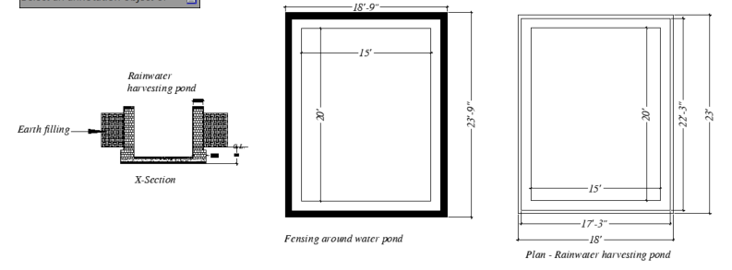
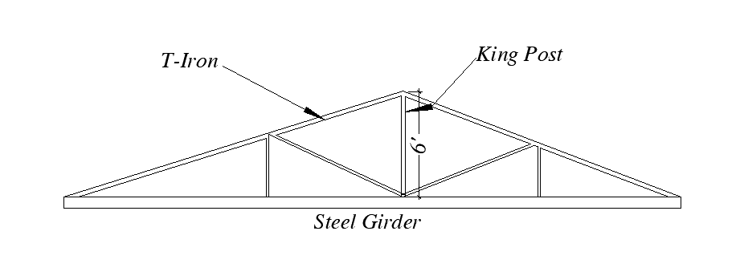
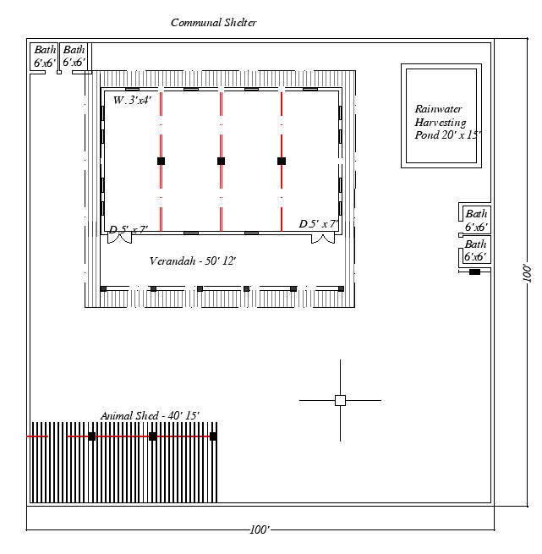

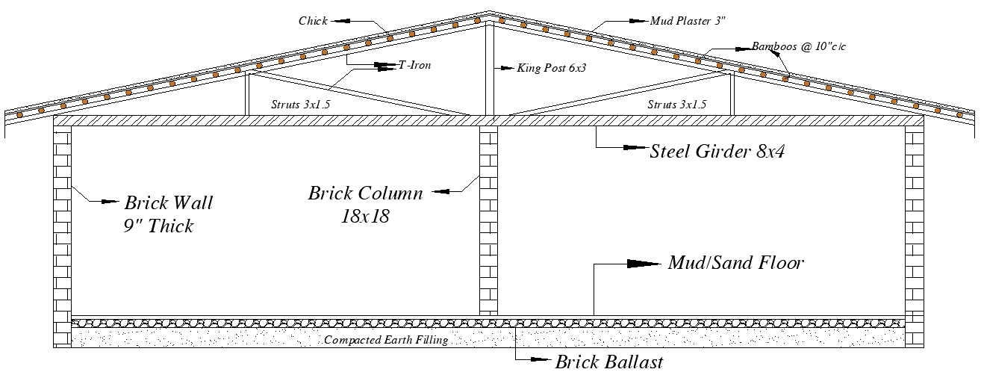
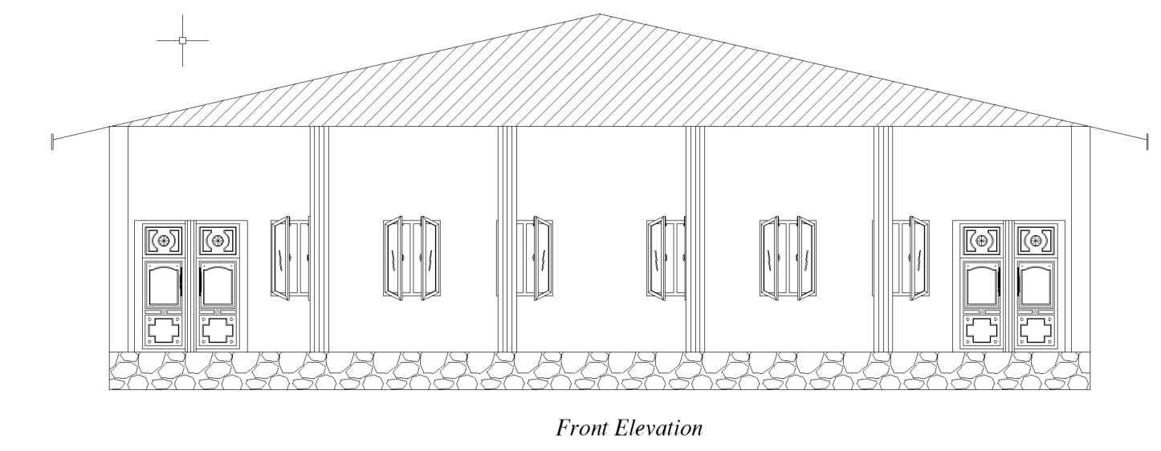

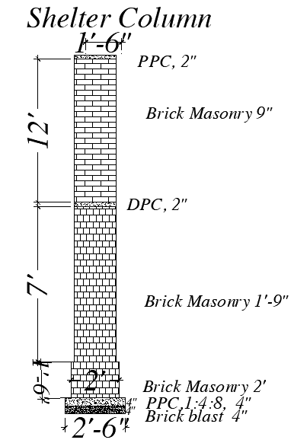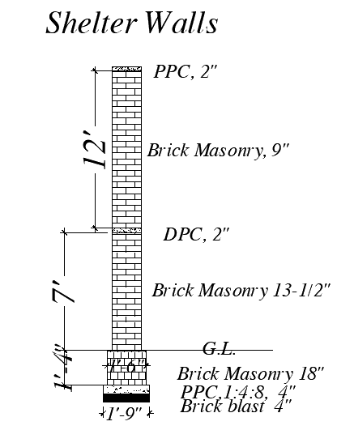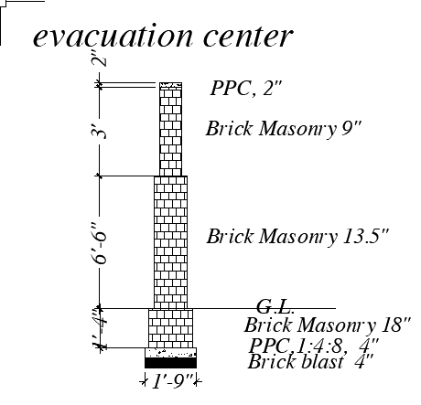
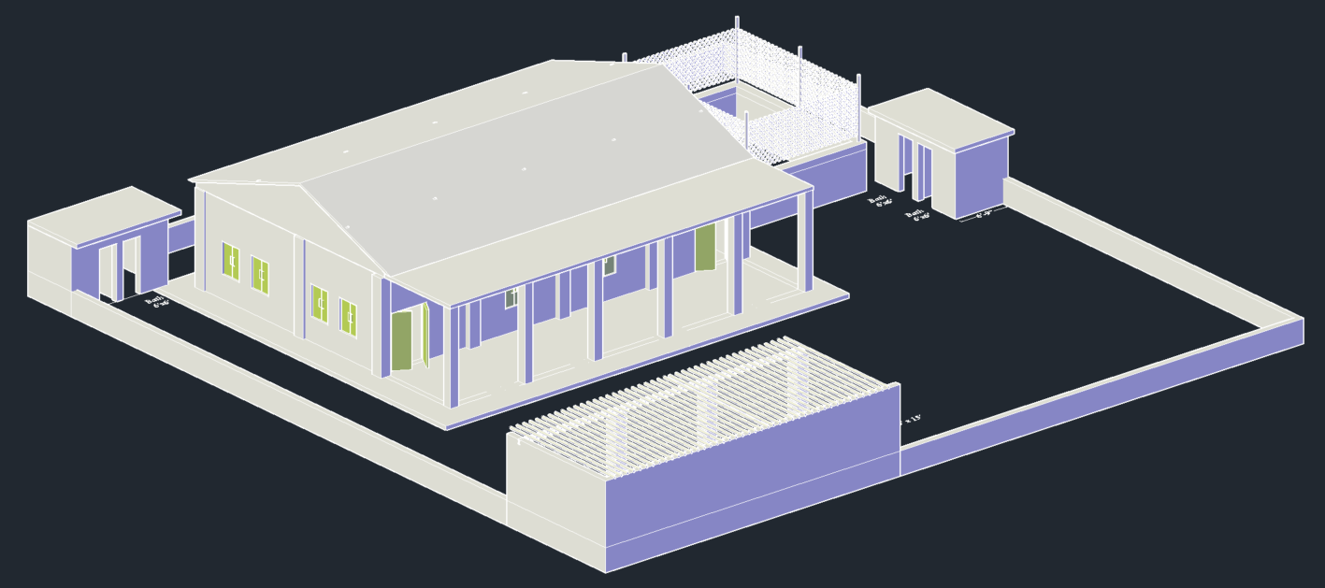

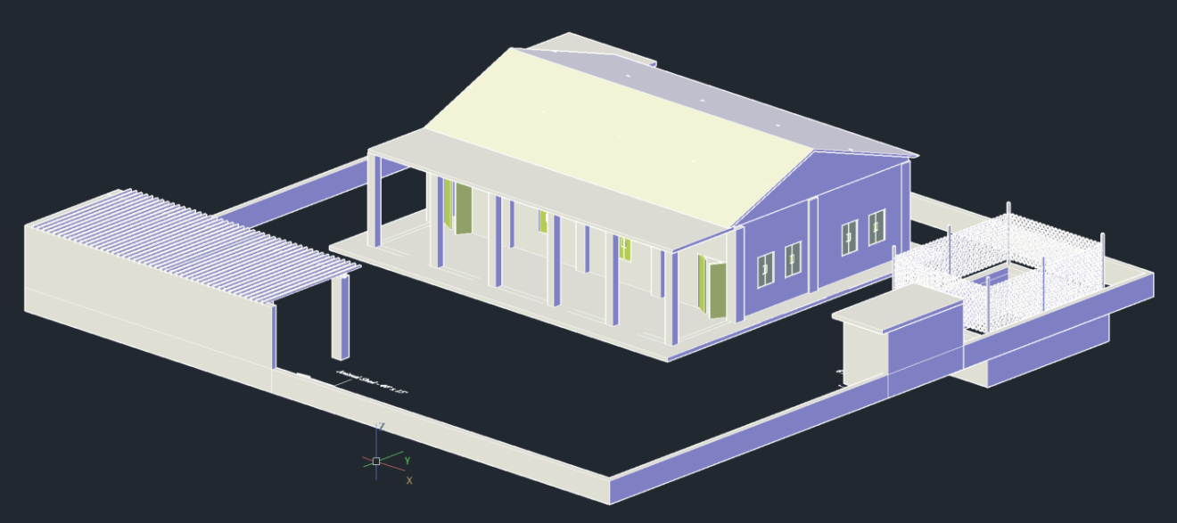

ANNEX – 2 – SITE LIST

Details of Sites for Construction of Disaster Resilient Communal Shelters
Sites for Communal Shelter Construction District Sanghar Sindh
S.NO | District | Tehsil | UC | Distance from main City
1 | Sanghar - Sindh | Sanghar | Bobi | Within the radius of 50 KM
2 | Sanghar - Sindh | Sanghar | Daro Bazar | Within the radius of 50 KM
3 | Sanghar - Sindh | Sanghar | Bahram Bari | Within the radius of 50 KM
4 | Sanghar - Sindh | Khipro | Loon Khan | Within the radius of 50 KM
5 | Sanghar - Sindh | Khipro | Khori | Within the radius of 50 KM
Sites for Communal Shelter Construction District Jacobabad Sindh
S.NO | District | Tehsil | UC | Distance from main City
1 | Jacobabad - sindh | Thull | Balochabad | Within the radius of 35 KM
2 | Jacobabad - sindh | Thull | Bachro | Within the radius of 35 KM
3 | Jacobabad - sindh | Jacobabad | Ghari Chand | Within the radius of 35 KM
4 | Jacobabad - sindh | Jacobabad | Shahpur | Within the radius of 35 KM
5 | Jacobabad - sindh | Jacobabad | Qadir pur | Within the radius of 35 KM
Sites for Communal Shelter Construction District Jaffarabad Balochistan
S.NO | District | Tehsil | UC | Distance from main City
1 | Jaffarabad - Balochistan | Jhatpat | Manjhoti | Within the radius of 20 KM
2 | Jaffarabad - Balochistan | Jhatpat | Tharri | Within the radius of 20 KM
3 | Jaffarabad - Balochistan | Jhatpat | Bago Band | Within the radius of 20 KM
4 | Jaffarabad - Balochistan | Jhatpat | Yatgarh | Within the radius of 20 KM
5 | Jaffarabad - Balochistan | Jhatpat | Naseerabad | Within the radius of 20 KM

