SAMPLE PICTURES FOR UNDERSTANDING OF THE TYPE OF MATERIALS
Note: the supplier could propose similar materials base on the material specifications, Bid rates and availability of the markets
- Doors lintel- I Beam

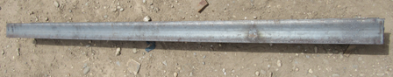

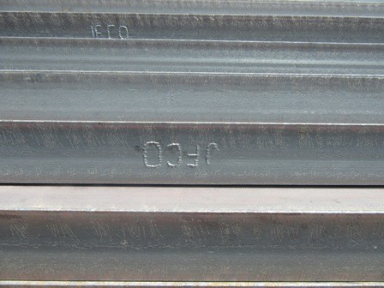
- Windows lintel - I Beam

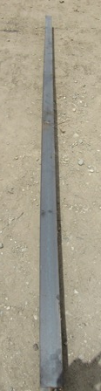
- Rooms and hall Iron beam for roof

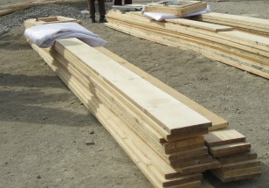
- Plank- Wooden.

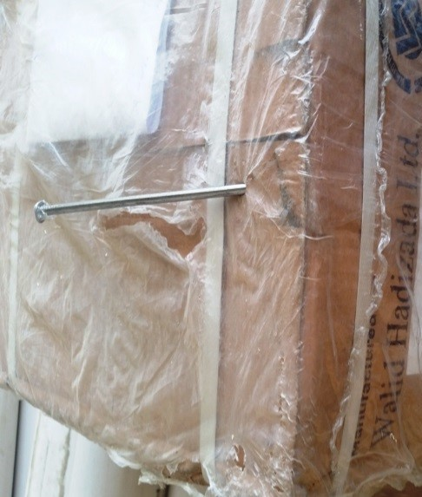
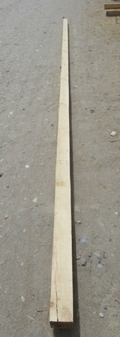
5-Earthquake resistance(Katiba)-Wooden

6-Nails-Iron 3inch

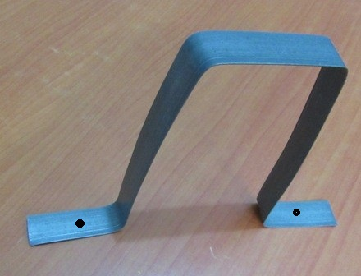
7-Iron plate 2mm thick

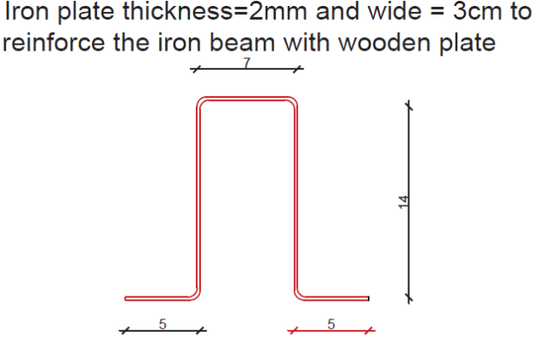
8-

9-.Door -Khar Wooden (please follow details drawing below)
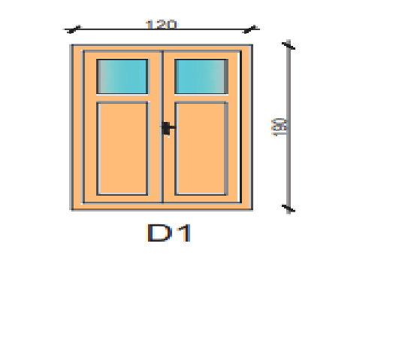

10-Door -Khar Wooden (please follow details drawing below)
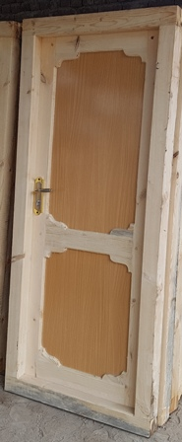

11-Windows -Khar Wooden (please follow details drawing below)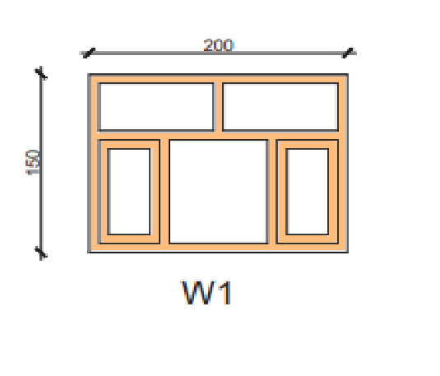

12- Window for corridor -Khar Wooden. (please follow details drawing below)
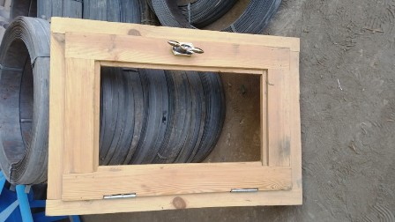

13 -Gutters from Iron sheet.
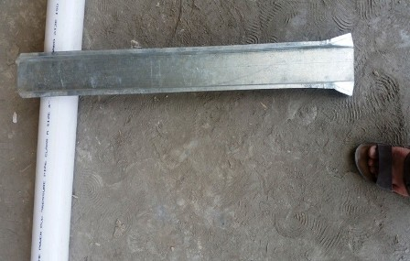

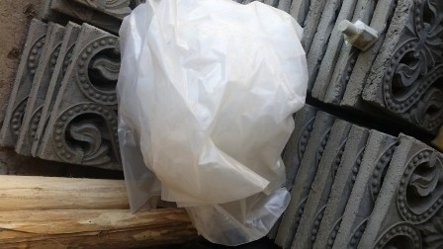
14-Plastic for roofing

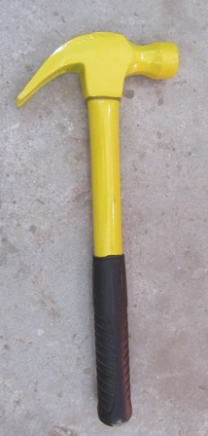
15-Claw Hammer (Weight with handle 760 grams)

16-Pick digger
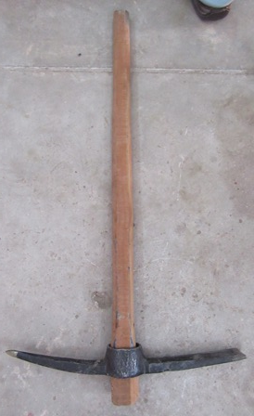

17-- Shovel (with wood handle)
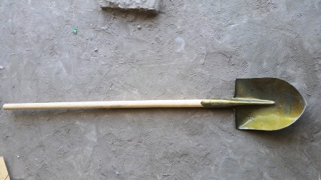

18-Handheld saw

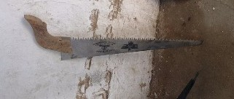

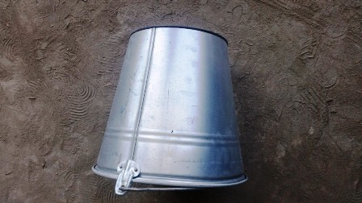
19-– Bucke

20– Wheelbarrow
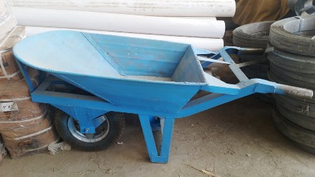

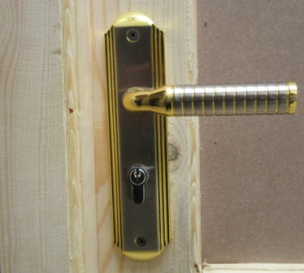
21-Lock for the Door

Latrine Materials for Shelter Program:-
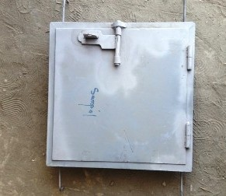
- Vault steel door .

- PVC vent pipe
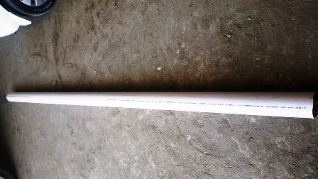

- Vent pipe hood from Iron sheet.
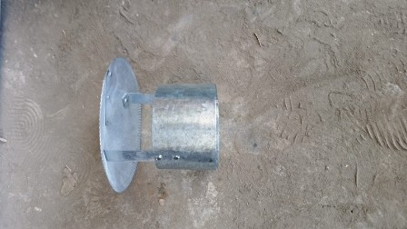

- Zinc pipe with T elbow.
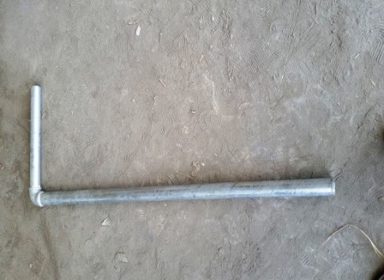

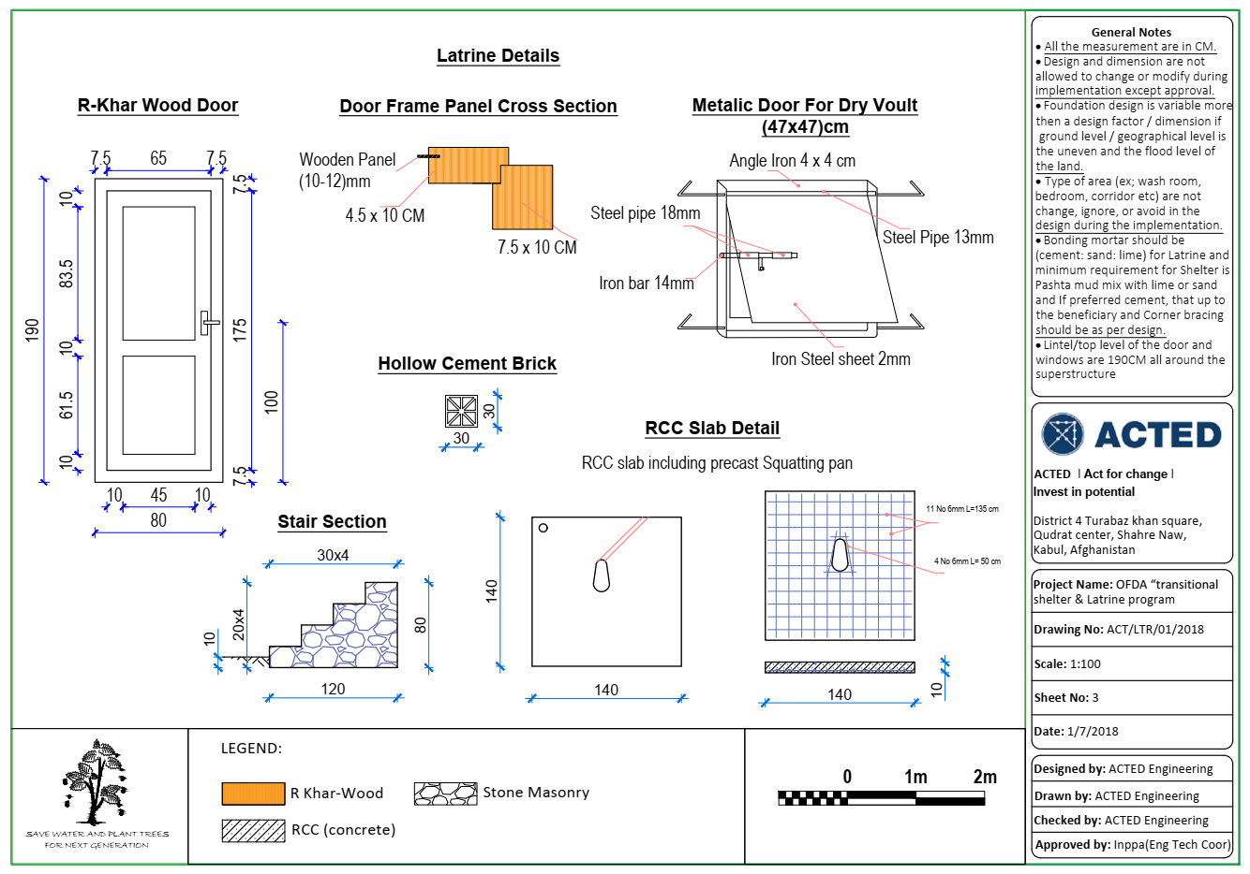
Details of the Latrine drawing-related to materials

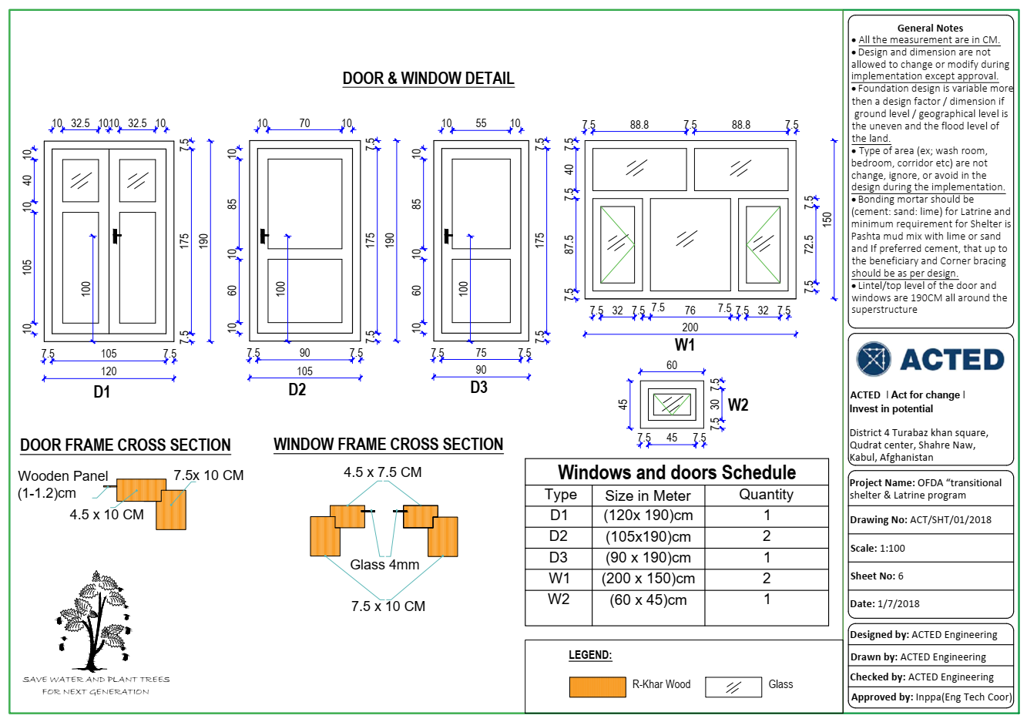
Details of the Shelter drawing-related to materials

